Task on Load Balancers

1.Configure Classic Load balancer.
Task Title
Configure a Classic Load Balancer in AWS
Objective
Set up a Classic Load Balancer to distribute HTTP traffic across EC2 instances hosted in multiple Availability Zones.
Prerequisites
• VPC
• Public Subnets in at least 2 AZs
• EC2 Instances with web server installed
• IAM Role (if logs or S3 access needed)
• Key Pair
• Security Groups for EC2 & ELB
• Route Tables properly associated
• AMI (Amazon Linux 2 image)
Step-by-Step Implementation (With Evidence)
Step 1: Launch two EC2 instances
Console Path:
EC2 → Instances → Launch Instance
Actions:
• Choose Amazon Linux 2
• Select public subnet (AZ-A and AZ-B)
• Assign security group allowing port 80
• Add user data to install web server
User Data:
#!/bin/bash
yum install -y httpd
echo "Server $(hostname) — Classic Load Balancer Test" > /var/www/html/index.html
systemctl start httpd
systemctl enable httpd
Evidence:
• Screenshot of Instances page showing running state
Public-ec2-1
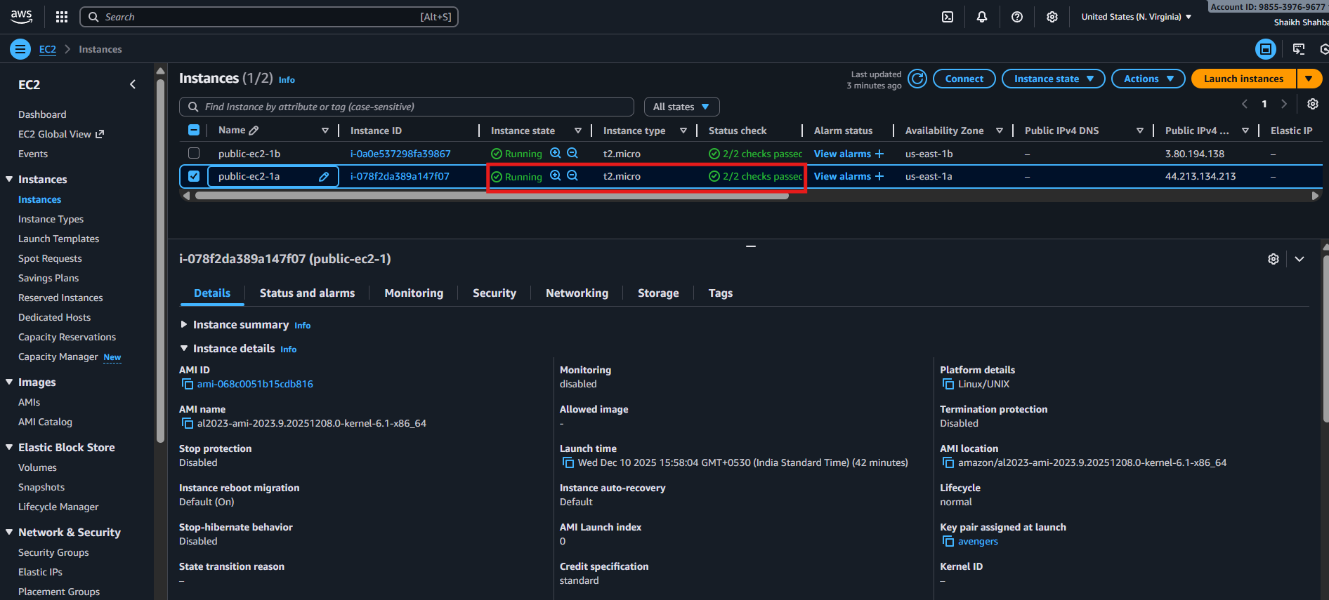
Public-ec2-1b
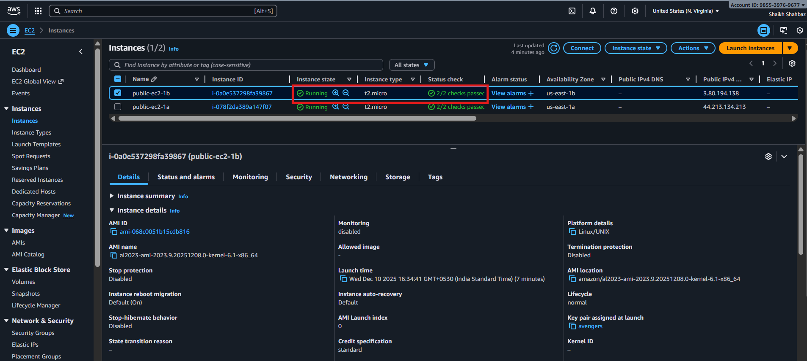
Evidence:
• Browser screenshot loading the page
Public-ip of ec2-1a :
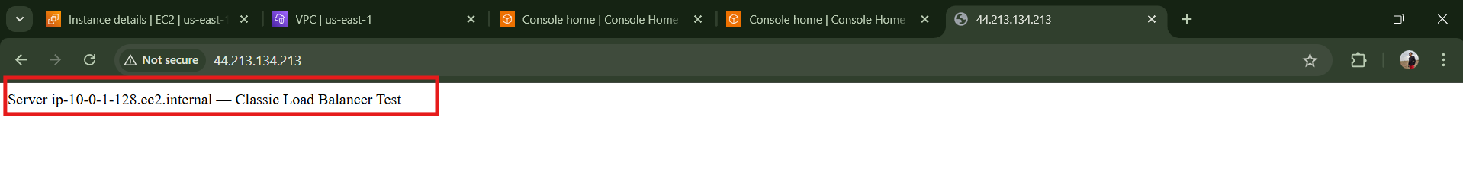
Public-ip of ec2-1b :
Step 3: Create Classic Load Balancer
Console Path:
EC2 → Load Balancers → Create Load Balancer → Classic Load Balancer
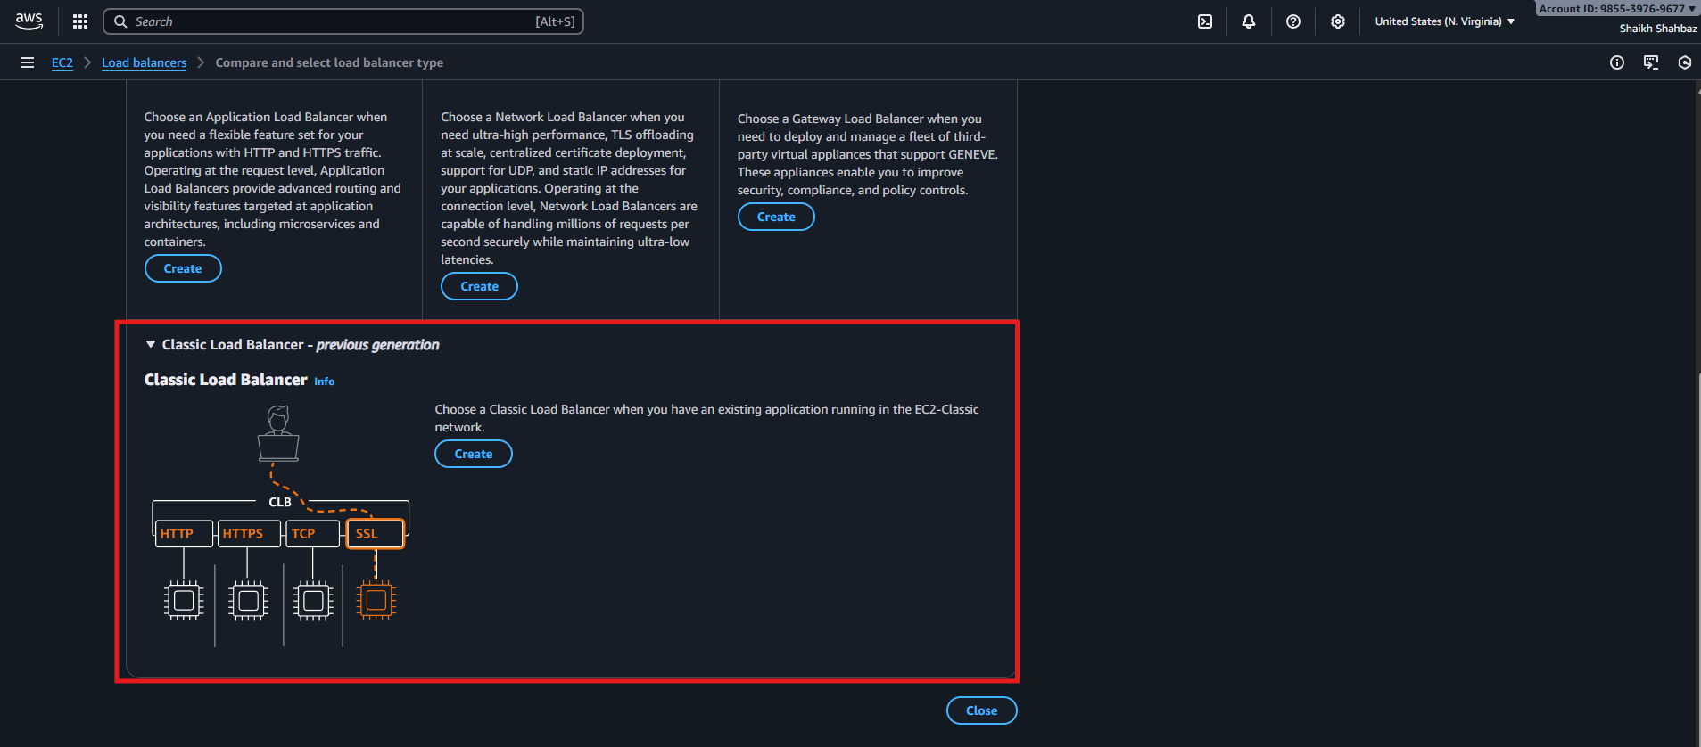
Actions:
• Name: classic-lb-demo
• Scheme: internet-facing
• Listener: HTTP 80 → 80
• Select 2 public subnets
• Select ELB security group (allow 80)
Evidence:
• Screenshot of CLB creation wizard
• Screenshot of listener configuration
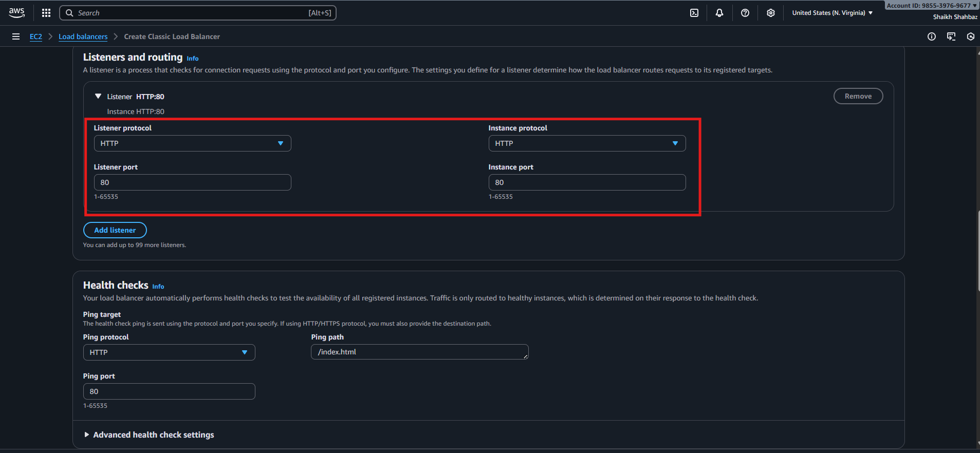

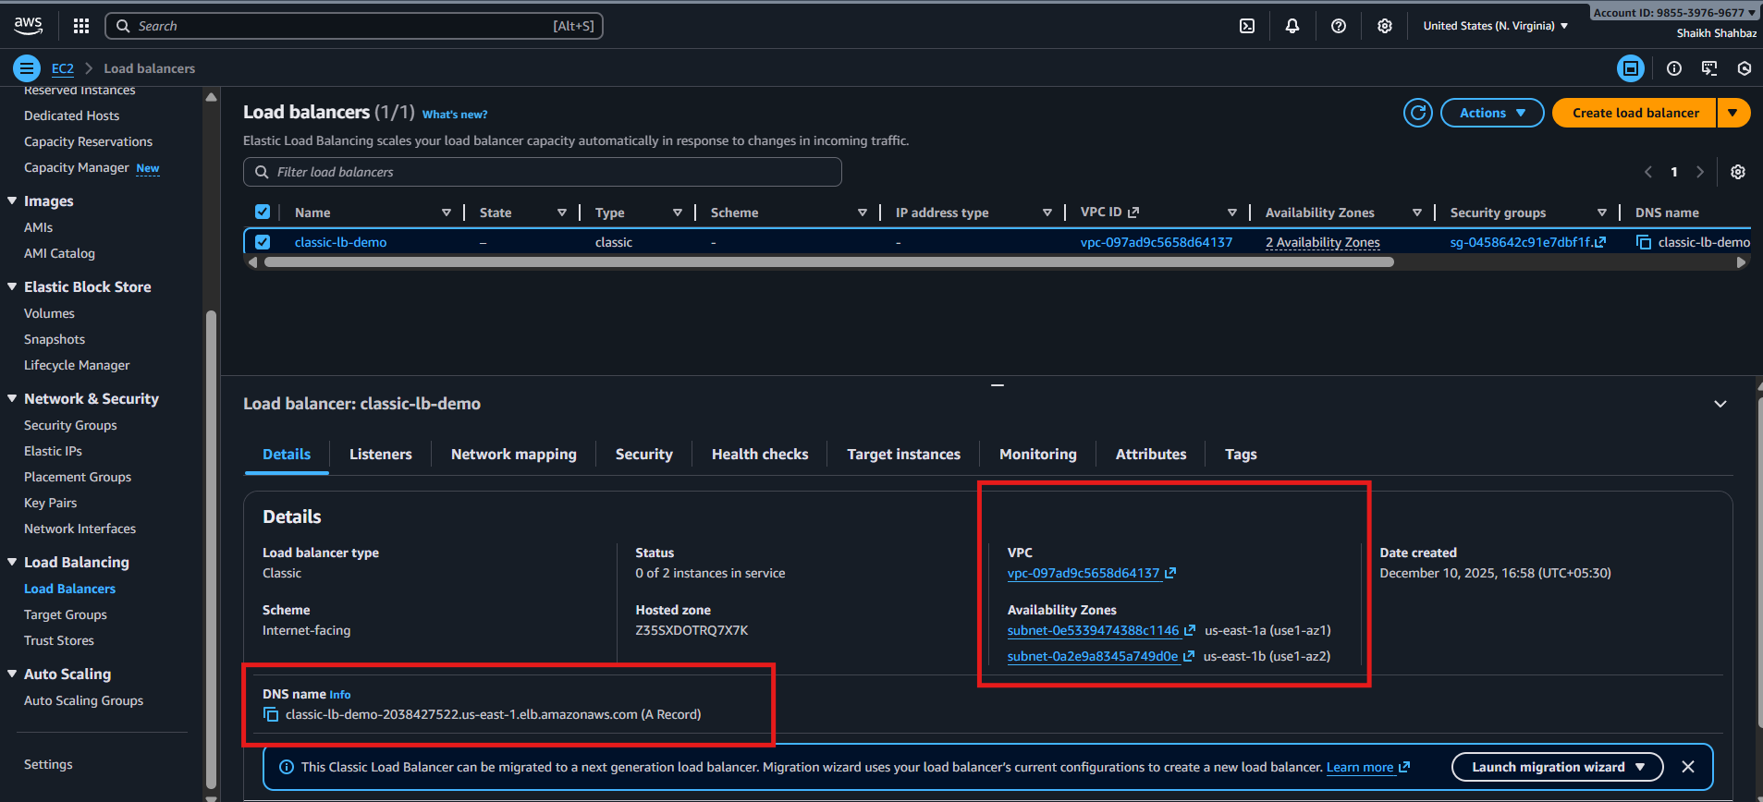

Step 4: Configure Health Checks
Settings:
• Ping Protocol: HTTP
• Ping Path: /
• Response Timeout: 5 seconds
• Healthy Threshold: 3
• Unhealthy Threshold: 2
Evidence:
• Screenshot of health check configuration page
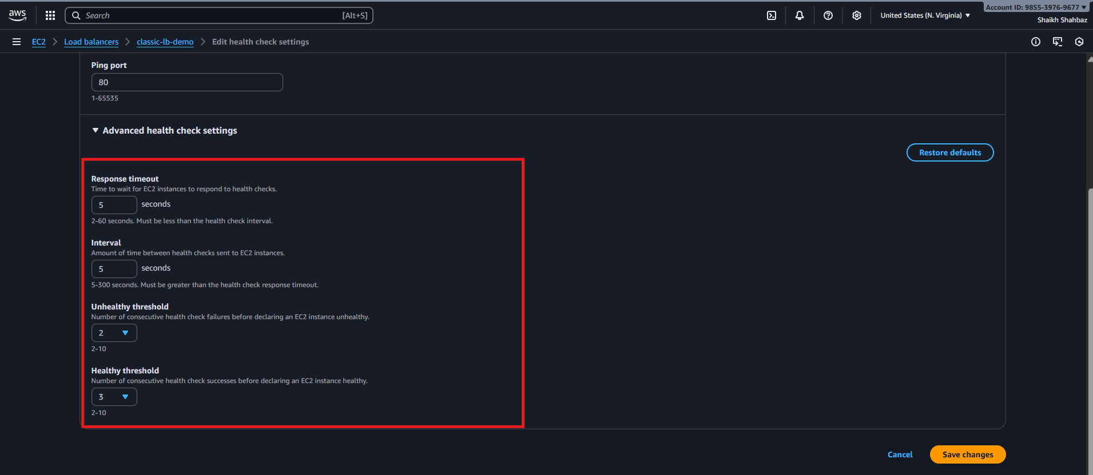
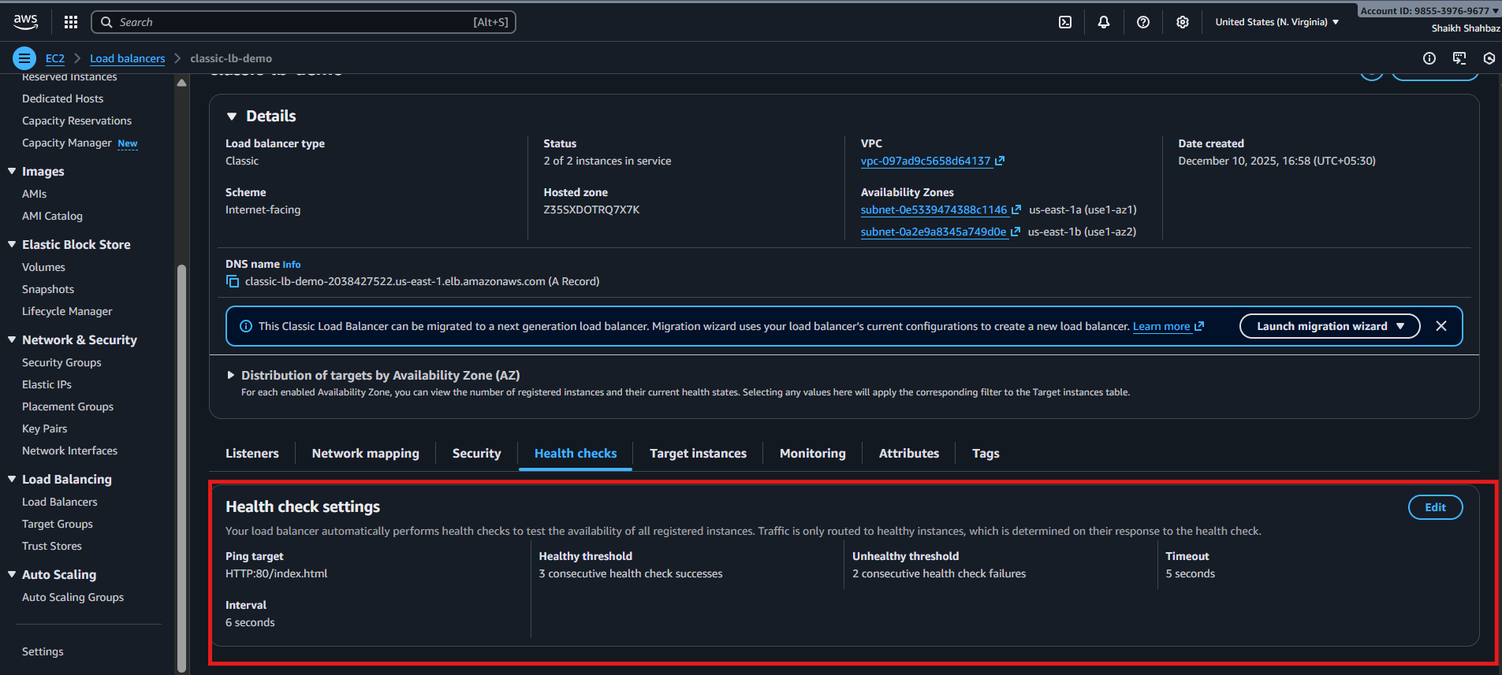
Step 5: Register EC2 Instances
Console Path:
Add both EC2 instances to Registered Instances
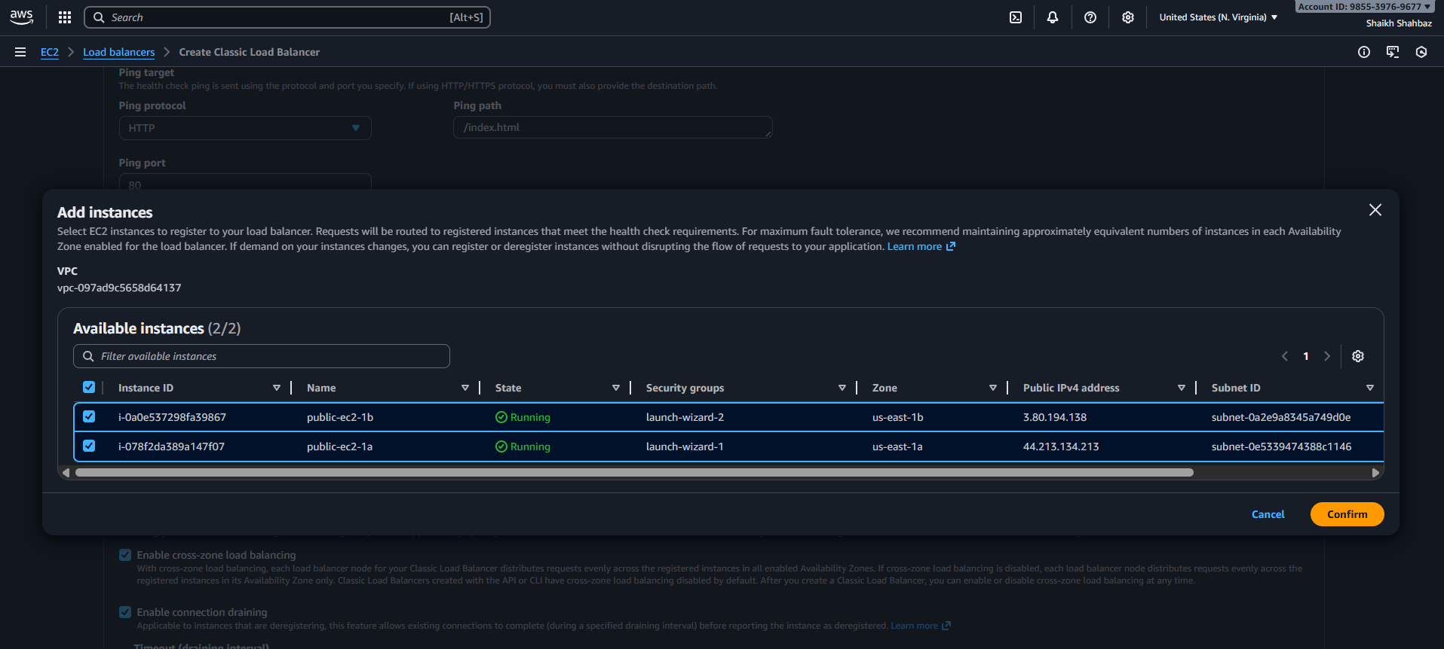
Explanation:
CLB starts performing health checks and changes state to InService.
Evidence:
• Screenshot showing EC2 instances as "InService" under CLB

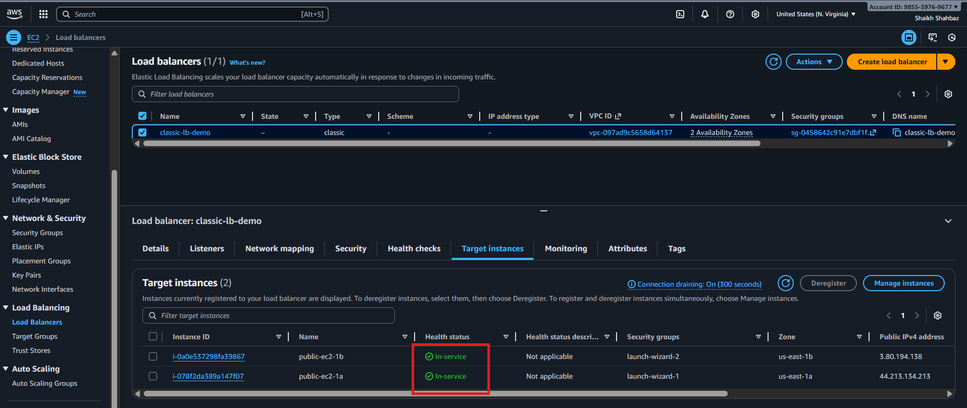
Validation Steps (Mandatory, With Evidence)
Validation 1: Resource Health
Check instance status:
• 2/2 checks passed
• InService under CLB
Evidence:
Screenshot: EC2 status checks + CLB registered targets
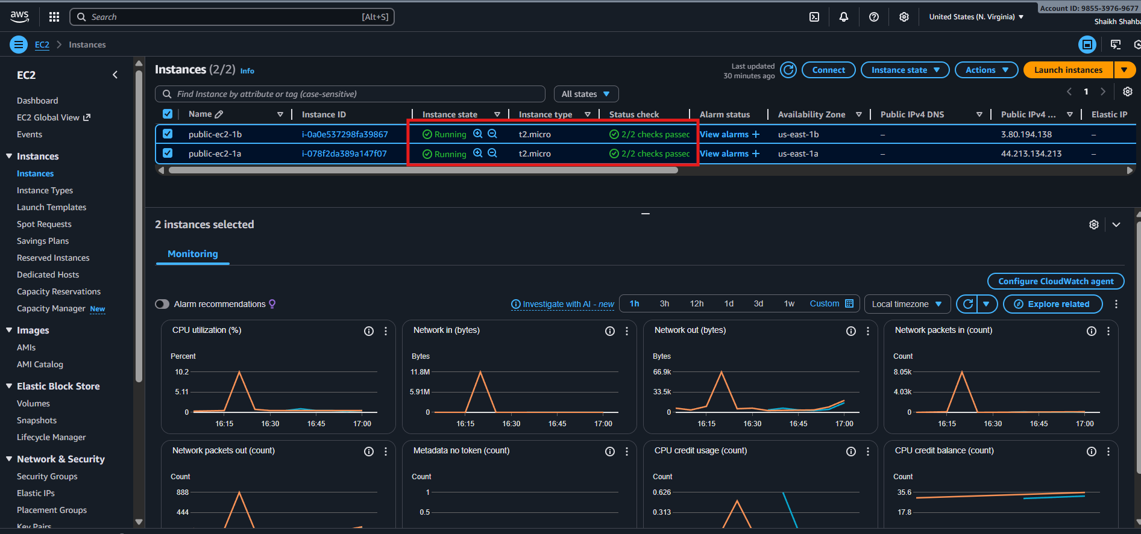
Validation 2: Functional Check
Open:
http:// classic-lb-demo-2038427522.us-east-1.elb.amazonaws.com
Refresh multiple times → responses alternate:
Evidence:
• Browser screenshot showing both server responses
Server ip-xx-xx-xx-xx — CLB Test
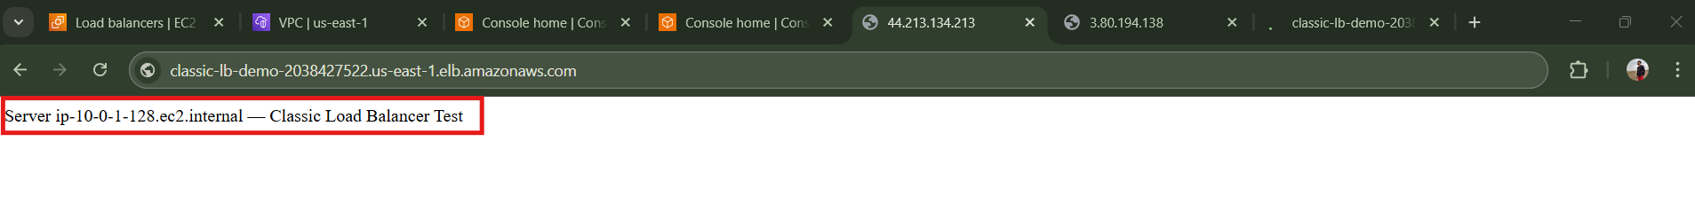
Server ip-yy-yy-yy-yy — CLB Test
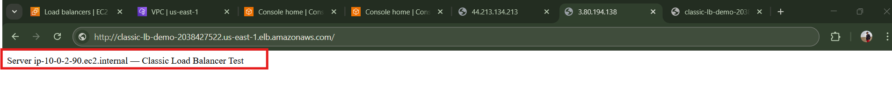

Validation 3: Network Check
SSH to instance:
curl http://localhost
Expected output from Apache server.
Evidence:
Terminal screenshot.
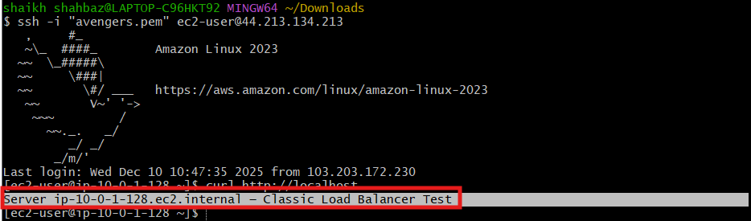
Issues Faced (Optional)
• Sometimes CLB shows "OutOfService" due to incorrect security group
Fix: Allow port 80 from the ELB security group to EC2 instances.
• If using custom AMI, Apache may fail to start
Fix: Verify user data executed correctly in /var/log/cloud-init-output.log.
Conclusion
Classic Load Balancer successfully configured to distribute HTTP traffic across EC2 instances, with verified health checks, network connectivity, and functional access.

2.Configure Application Load balancer.
Task Title
Configure Application Load Balancer (ALB)
Objective
Create an Application Load Balancer to distribute HTTP/HTTPS traffic across multiple EC2 instances using Layer 7 intelligent routing.
Prerequisites
Before starting, ensure the following are ready:
- VPC
- Public Subnets (min 2)
- IAM Role (EC2 Role – optional)
- Key Pair
- Security Groups (Allow HTTP/HTTPS)
- EC2 Instances (Web server installed)
- Route Tables configured
- Packages Installed (Apache/Nginx)
- Internet Gateway attached to VPC

Step-by-Step Implementation (With Evidence)
Step 1: Launch 2 EC2 Instances
Console Path:
EC2 → Instances → Launch Instance
Actions:
- Choose Amazon Linux 2
- Select Instance Type: t2.micro
- Put each instance in a different Availability Zone
- Install Apache on each instance:
sudo yum install -y httpd
sudo systemctl start httpd
sudo bash -c 'echo "Server $(hostname) responding through ALB" > /var/www/html/index.html'
Evidence (expected output):
- Apache running
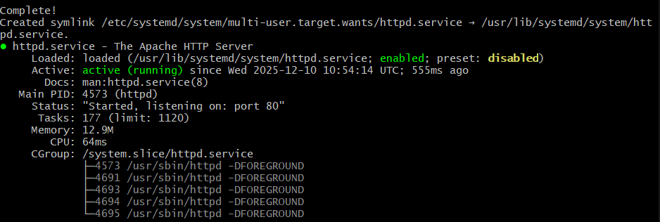
- Screenshot should show EC2 Status: Running + 2/2 Status Checks Passed
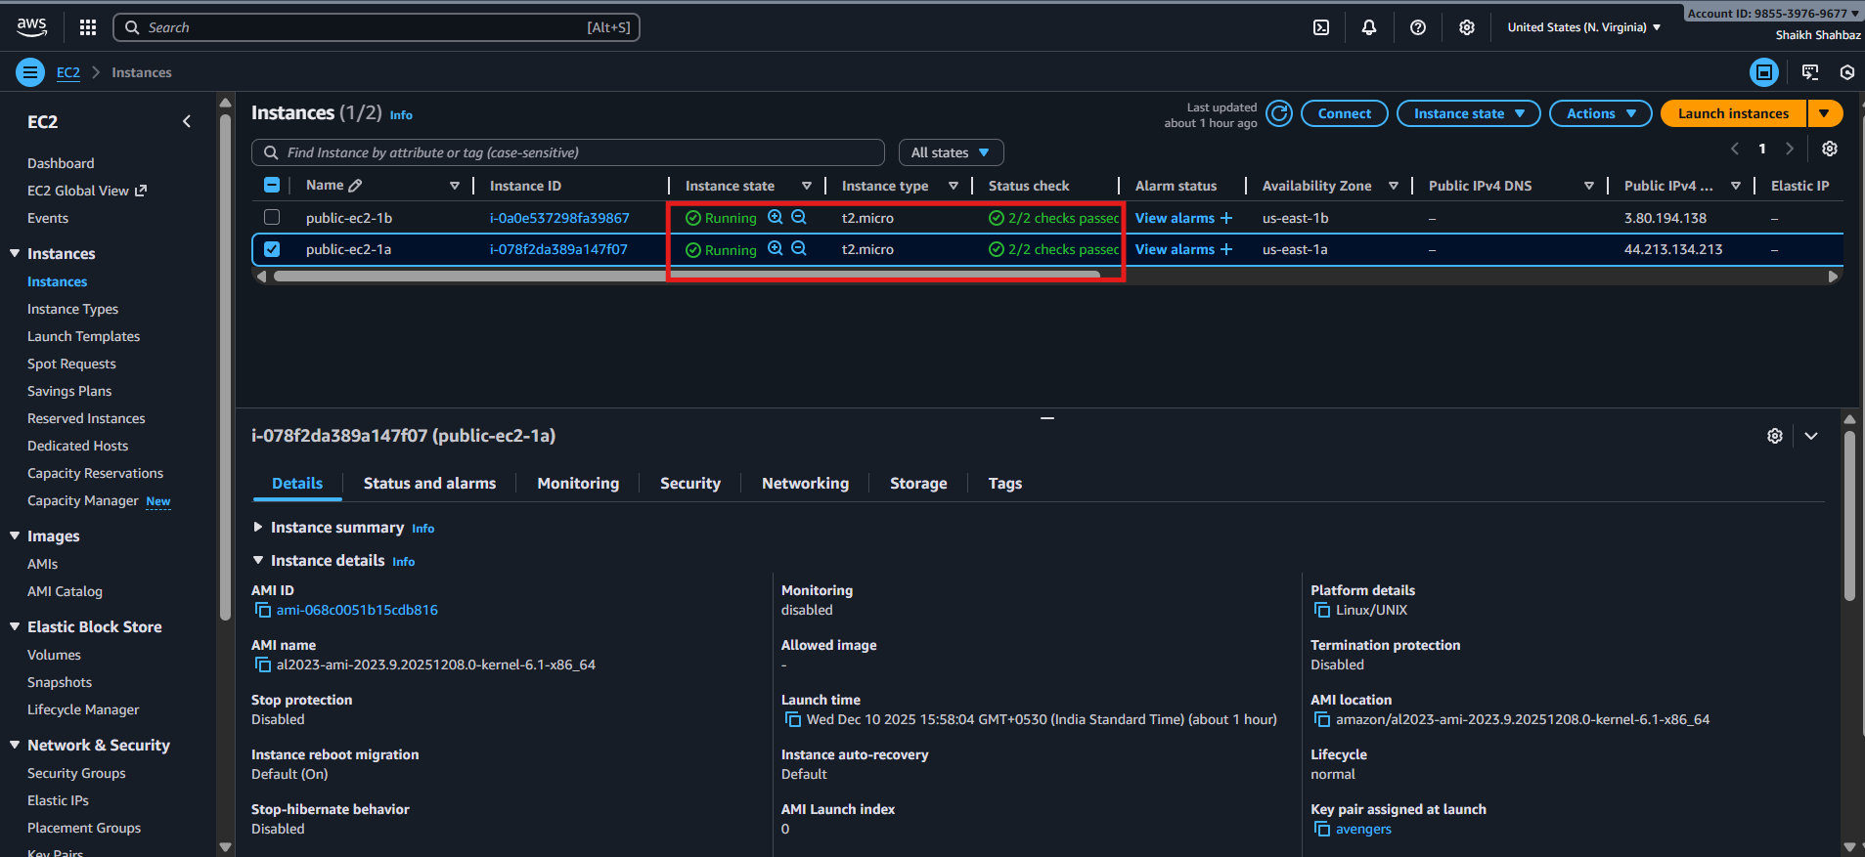
Step 2: Create a Target Group
Console Path:
EC2 → Target Groups → Create Target Group
Actions:
- Choose Instance target type
- Protocol: HTTP
- Port: 80
- Health Check Path: /
Register Targets:
- Select both EC2 instances
- Click Include as pending below → Create
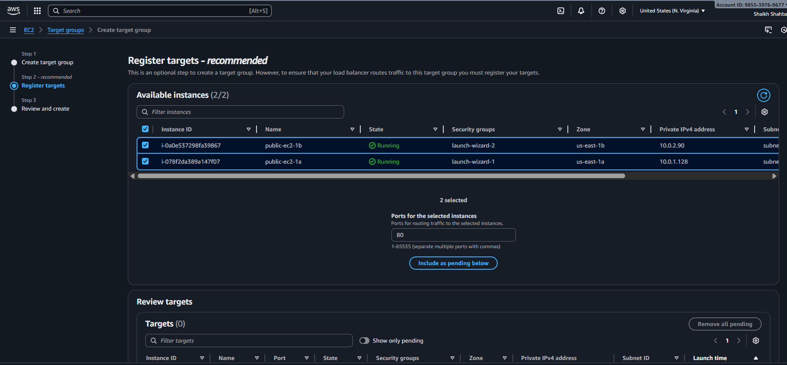
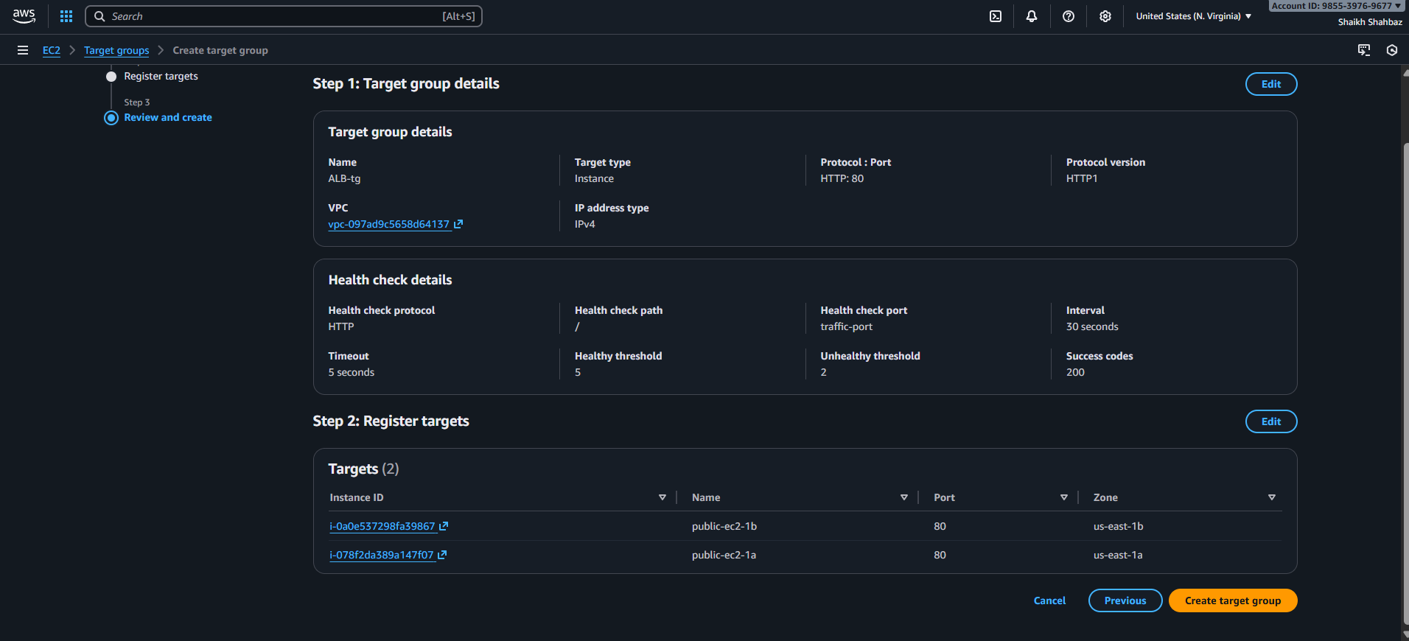
Evidence:
- Target Health: initial → healthy
- Screenshot: Both EC2 instances showing healthy
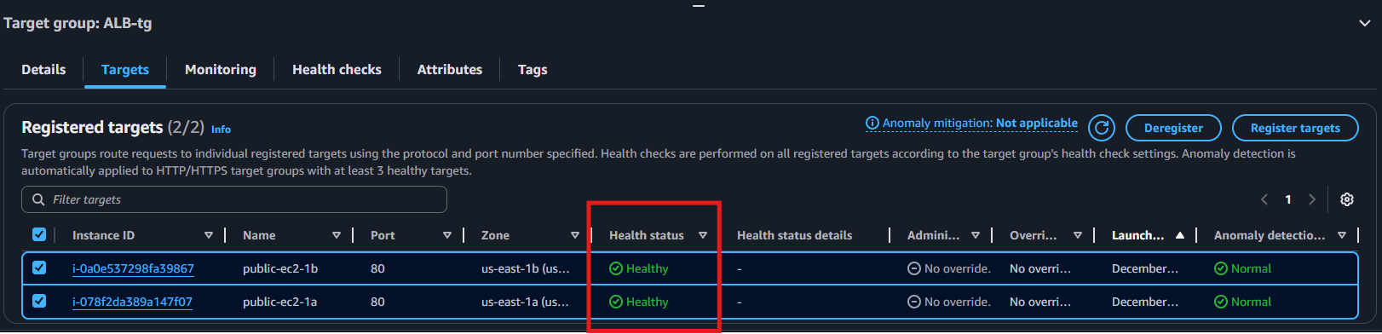
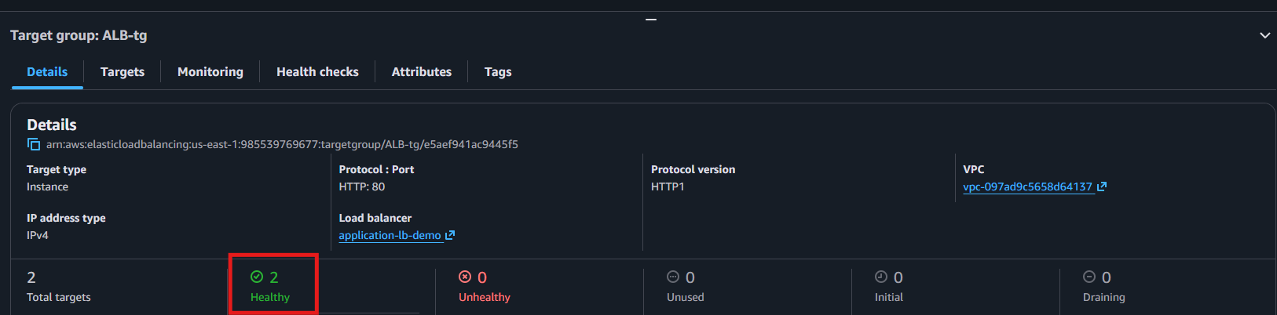
Step 3: Create the Application Load Balancer
Console Path:
EC2 → Load Balancers → Create Load Balancer → Application Load Balancer
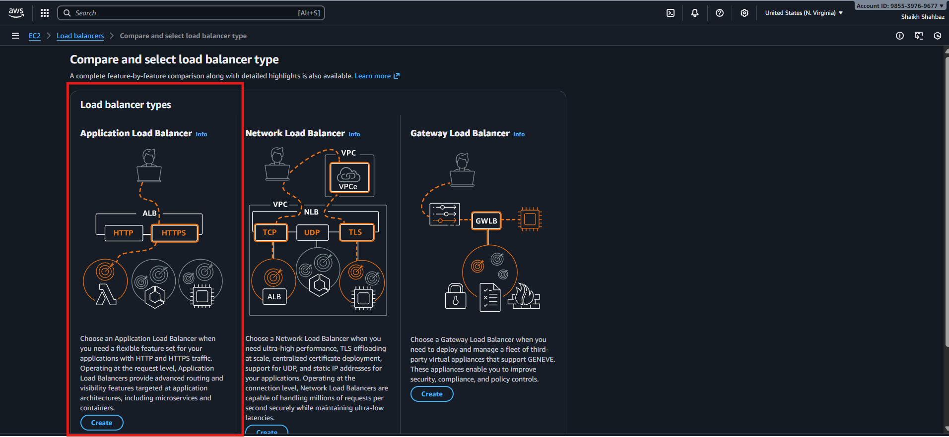
Actions:
- Name: application-lb-demo
- Scheme: Internet-facing
- IP Type: IPv4
- Select at least 2 subnets
- Security Group: Allow HTTP (80)
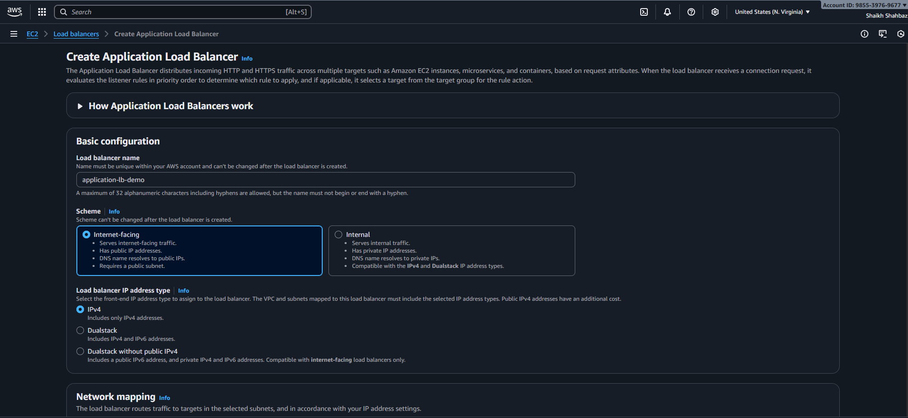
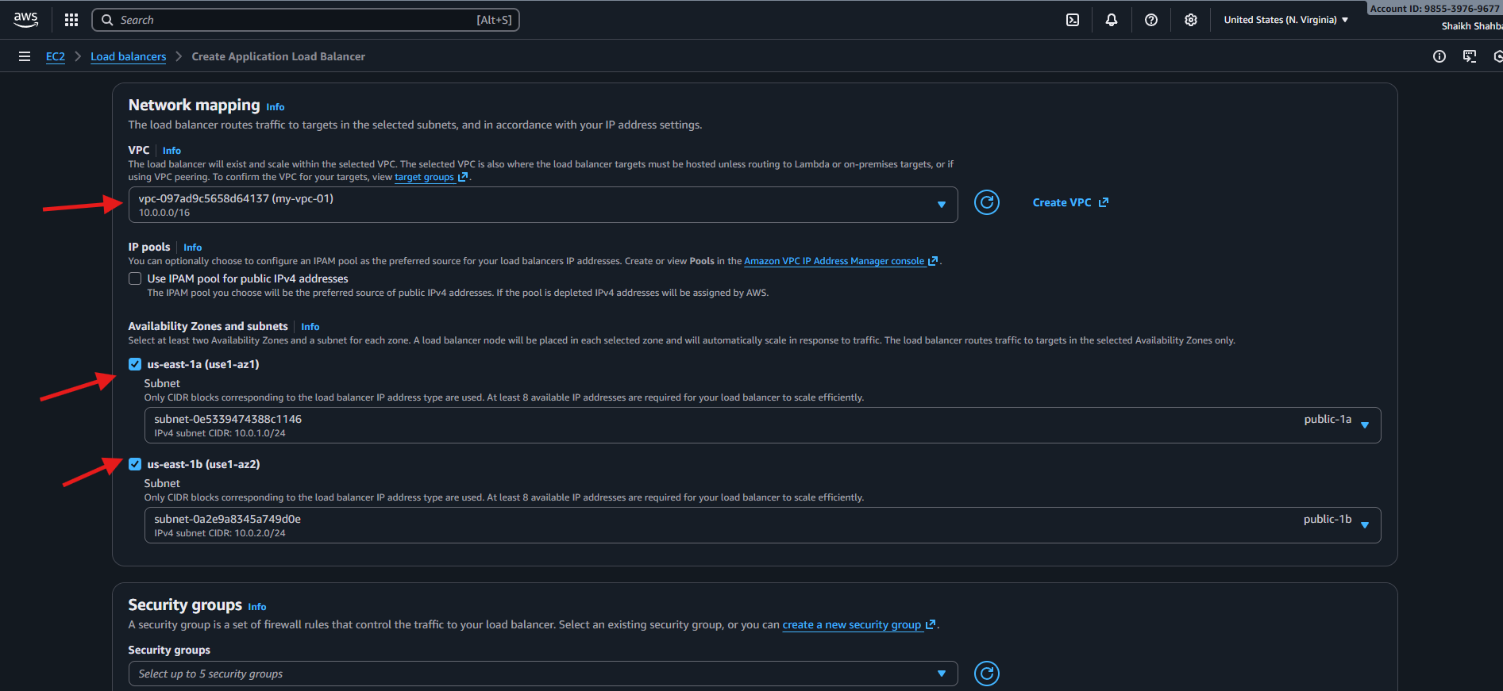
Listener Configuration:
- Listener: HTTP:80
- Action: Forward to Target Group created in Step 2
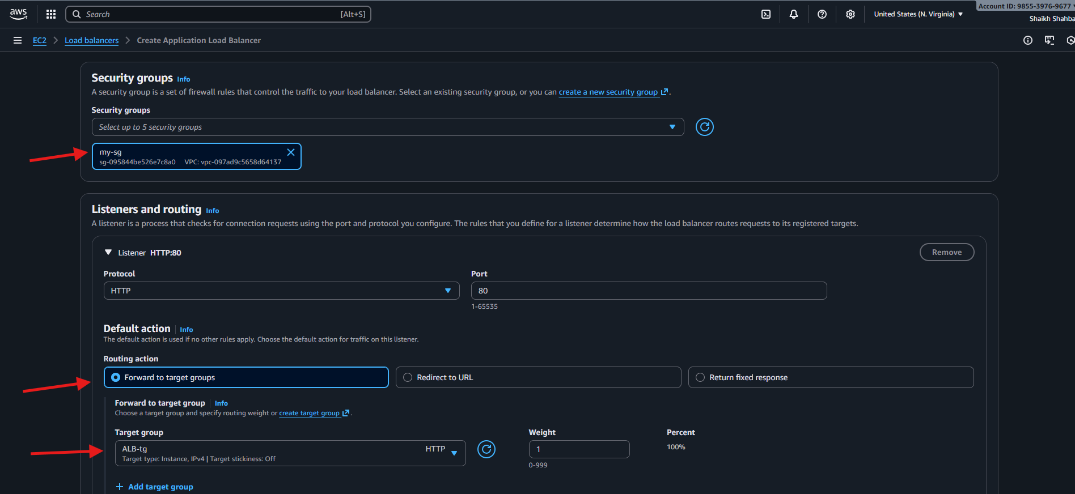
Evidence:
- ALB state: Provisioning → Active
- Screenshot: ALB details page showing DNS name
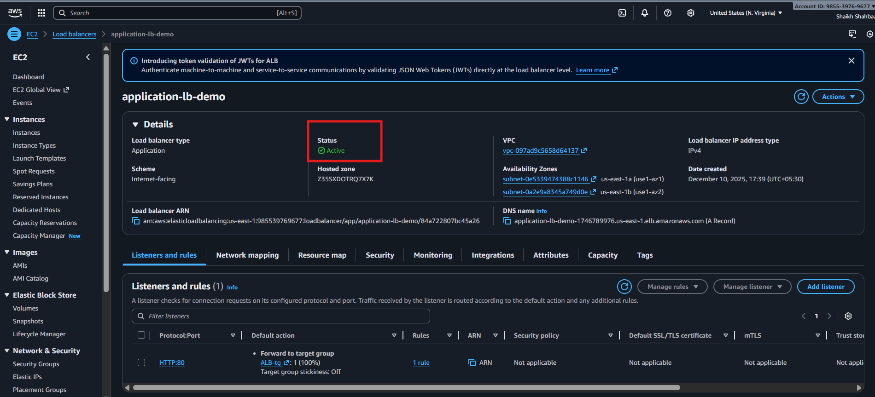
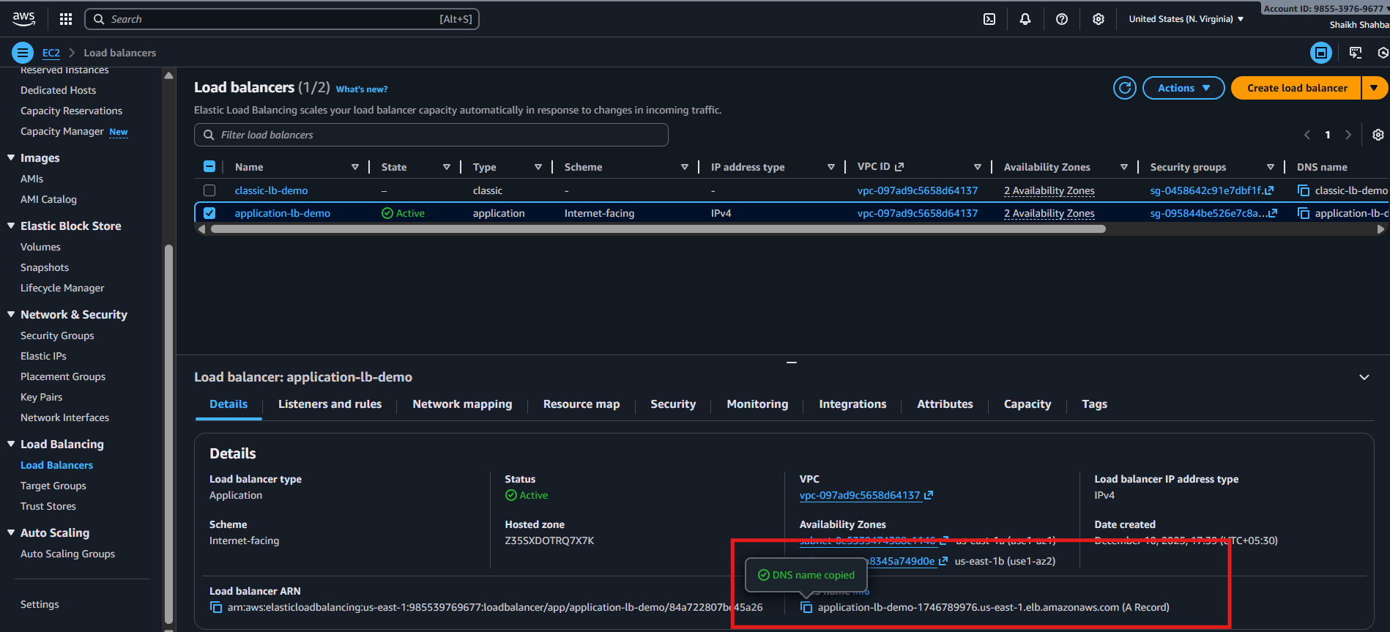
Step 4: Validate Health Checks
Console Path:
Target Groups → Your TG → Targets
Actions:
- Ensure status = healthy
Evidence:
- Green “Healthy” status for both instances
Step 5: Test ALB
Actions:
- Copy ALB DNS name:
http://my-app-alb-123456.region.elb.amazonaws.com
- Open in browser
- Refresh multiple times to see responses from Instance A and B
Expected Output:
- “Server ip-xx-xx-xx-xx responding through ALB”
- Response switching between instance A & B → load balancing confirmed
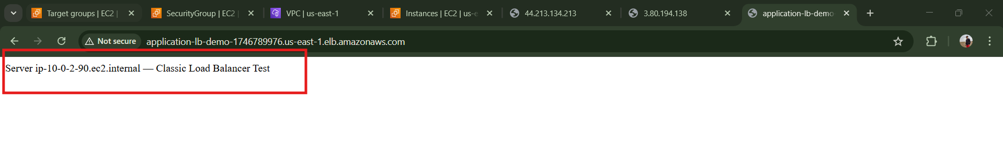
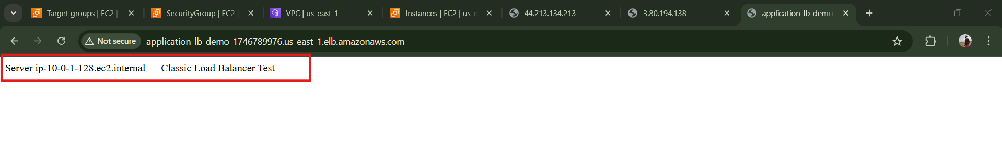
Validation Steps (With Evidence)
Validation 1: Resource Health
- EC2 instances Running
- Status checks = 2/2 passed
Evidence: EC2 instance screenshot
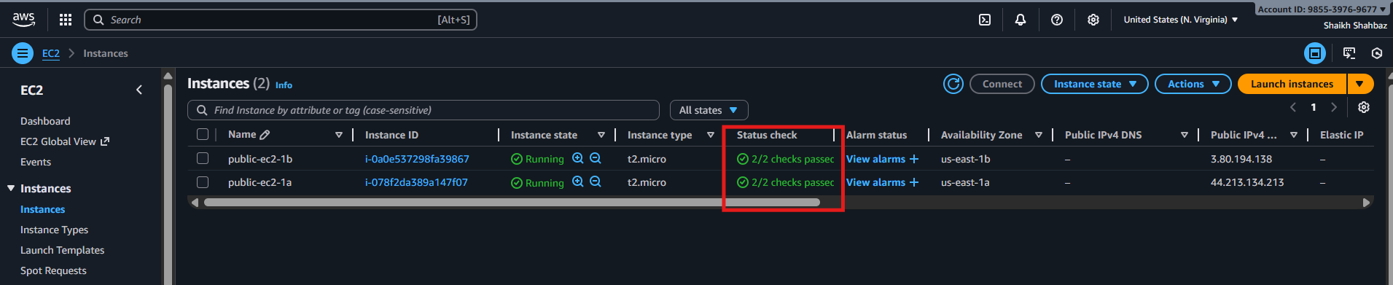
Validation 2: Load Balancer Health
- ALB state: Active
- Target health: Healthy
Evidence: Target group screenshot
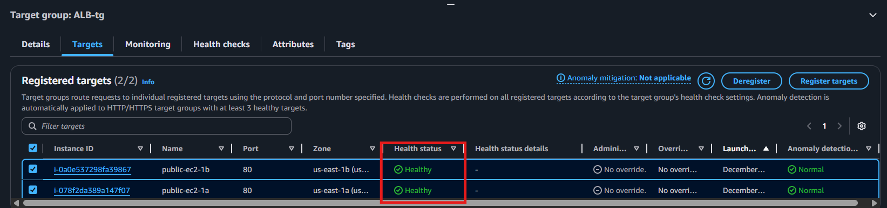
Validation 4: Network Check
From EC2:
ping google.com
curl amazon.com
This confirms outgoing internet and routing.
Evidence: Terminal screenshot
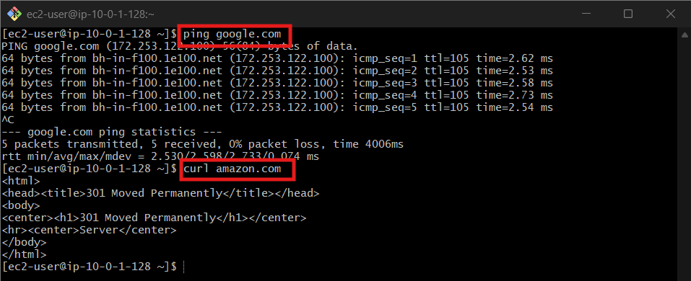
Issues Faced
Issue: Target group shows unhealthy
Fix:
- Ensure Apache is running
- Security group allows port 80
- Health check path is /
Conclusion
Application Load Balancer successfully configured with:
Layer 7 routing
Working health checks
Multiple EC2 targets
Verified functional load balancing

3.Configure Network Load balancer.
Task Title
Configure Network Load Balancer (NLB) in AWS
Objective
Set up a high-performance Layer 4 Network Load Balancer to distribute TCP traffic across EC2 instances with extremely low latency.
Prerequisites
- VPC (default or custom)
- Public Subnets in at least two AZs
- EC2 Instances (web server httpd)
- Security Groups for EC2 (NLB doesn’t use SGs)
- IAM Permissions
- Key Pair (avengers.pem)
- Route Tables
- Packages / AMI (if needed)
  - Amazon Linux 2
Step-by-Step Implementation (With Evidence)
Step 1: Launch EC2 Instances
Console Path:
EC2 → Instances → Launch Instance
Actions:
- Choose Amazon Linux 2 AMI
- Instance type: t2.micro
- Select 2 different AZs
- Attach SG allowing port 80
- SSH into each instance and install web server:
Command:
sudo yum install -y httpd
sudo systemctl start httpd
echo "Welcome from Instance 1" > /var/www/html/index.html
Evidence:
Attach EC2 running screenshot
SSH terminal showing httpd running
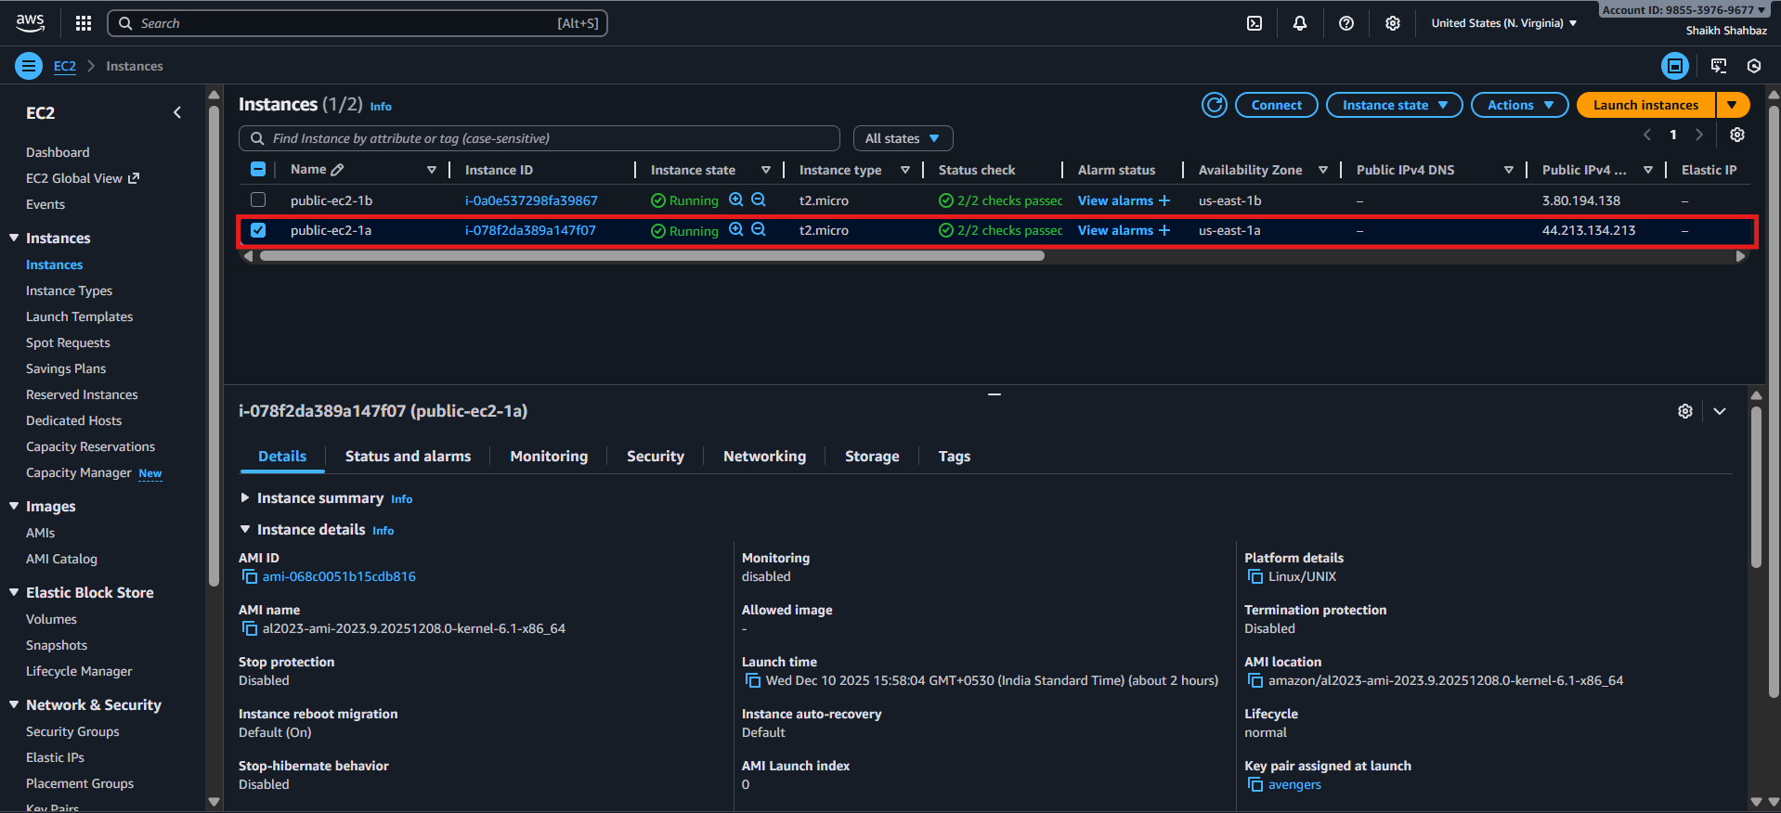
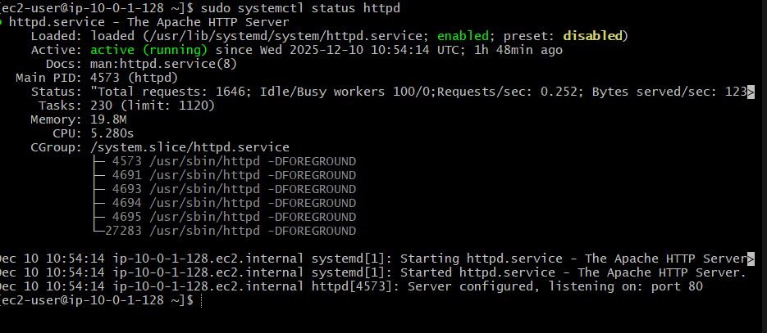
Step 2: Create Target Group for NLB
Console Path:
EC2 → Target Groups → Create Target Group
Actions:
- Target Type: Instances
- Protocol: TCP
- Port: 80
- Health check protocol: TCP
- Register the 2 EC2 instances
Evidence:
Target group “healthy” screenshot
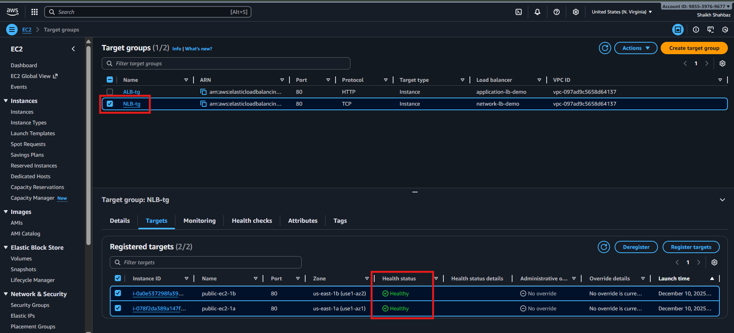
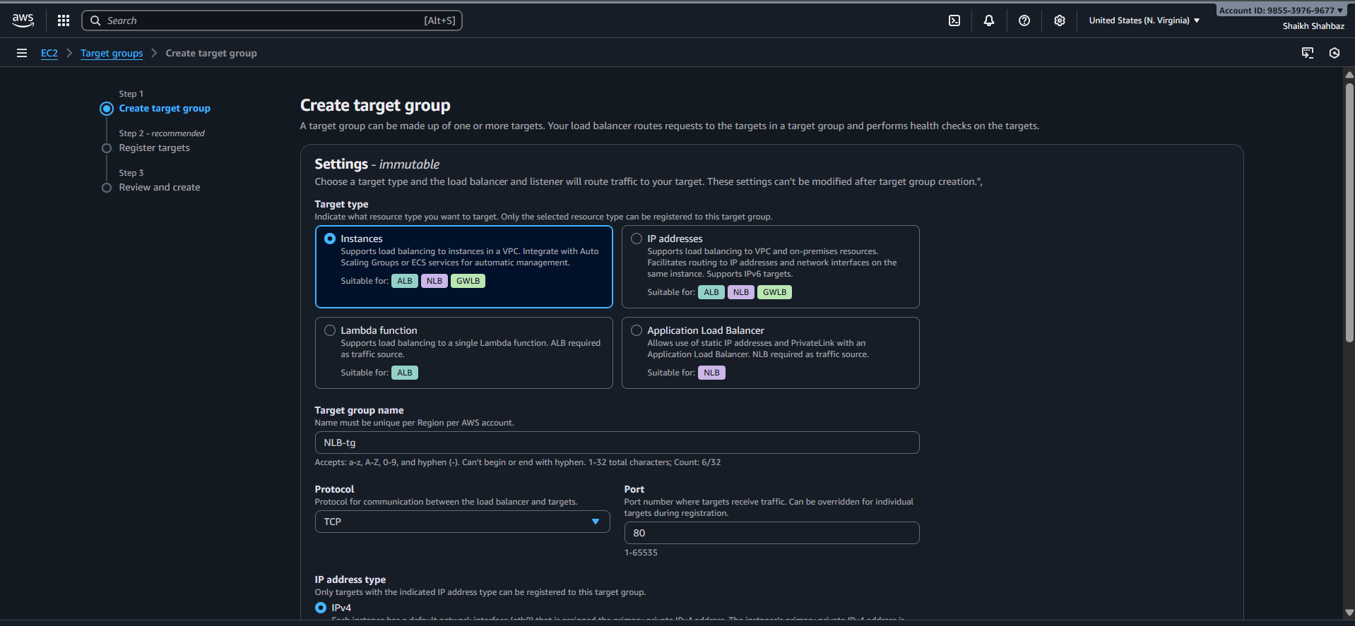
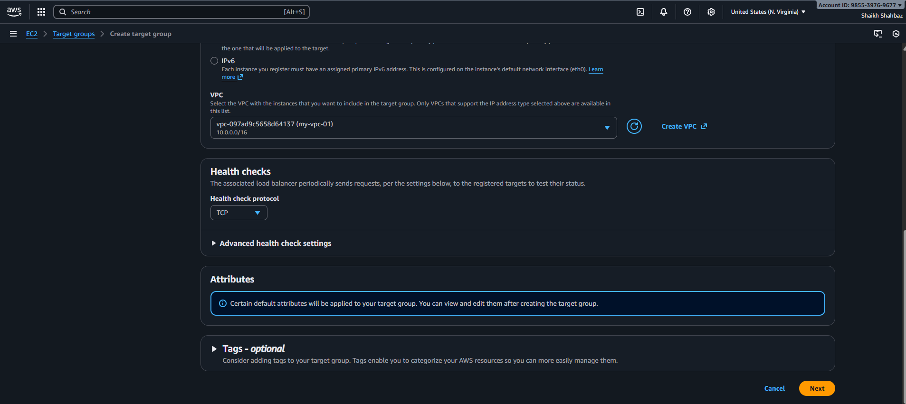

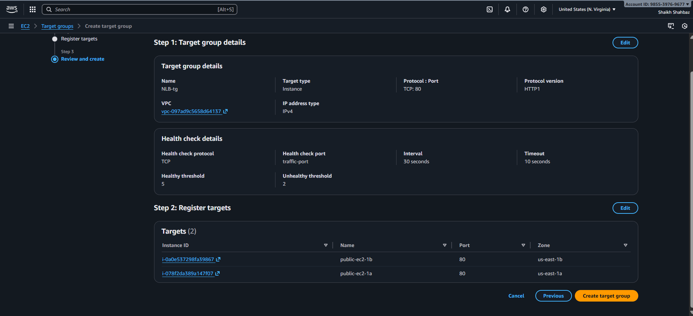
Step 3: Create Network Load Balancer
Console Path:
EC2 → Load Balancers → Create Load Balancer → Network Load Balancer
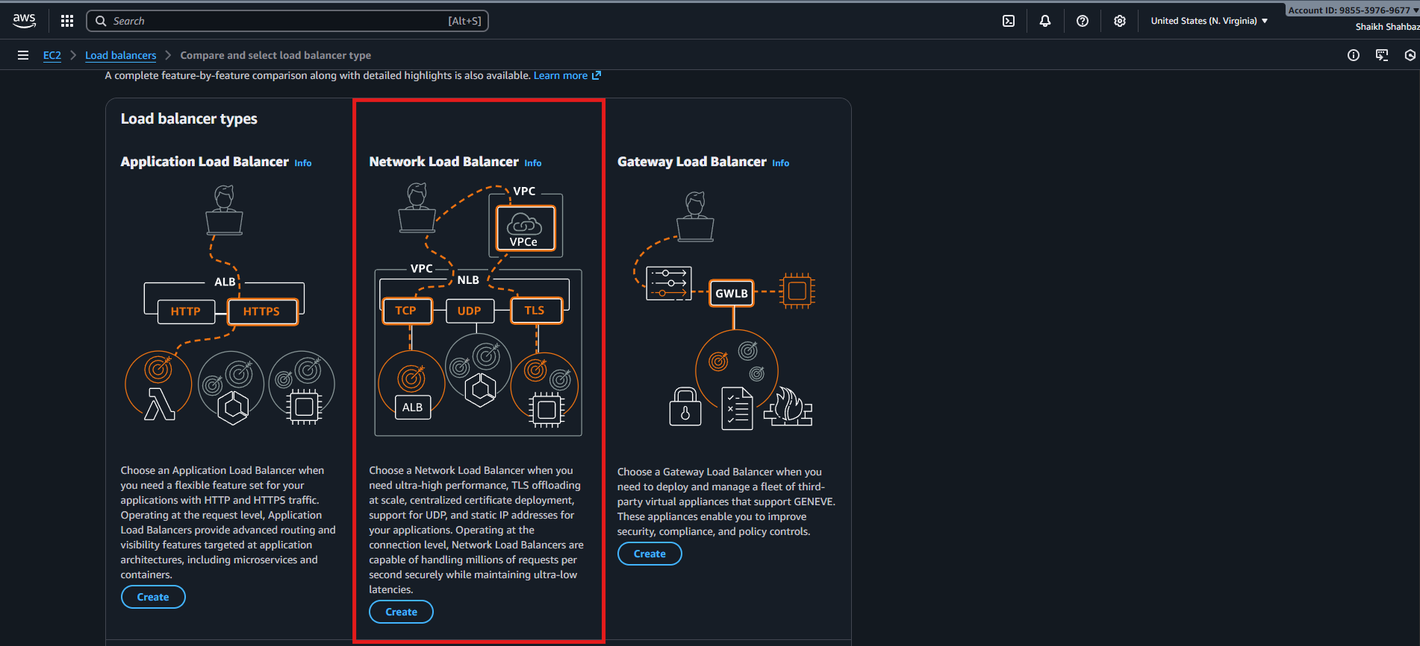
Actions:
- Name: network-lb-demo
- Scheme: Internet-facing
- Select at least two public subnets
- Listener configuration:
  - TCP : 80 → Target Group created earlier
Evidence:
NLB creation screen
Listener configuration screenshot
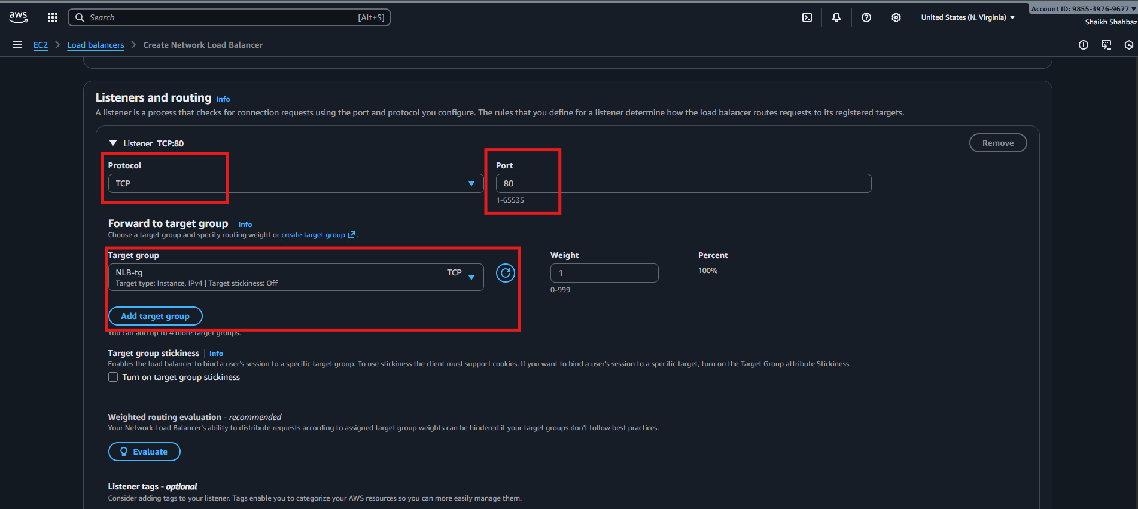
Step 4: Register Target Group to Listener
- Under Listeners → Forward to target group
- Select your created target group
Evidence: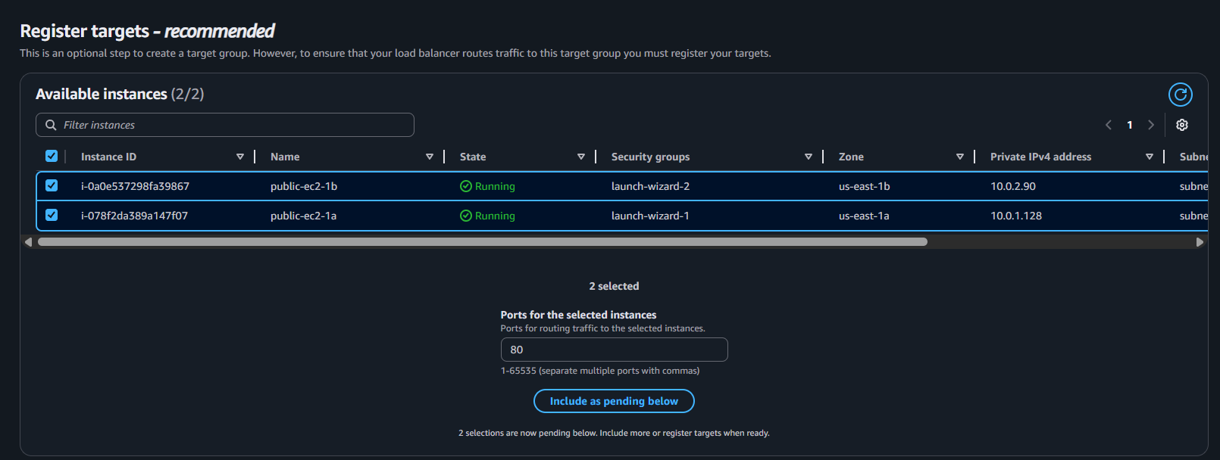

Step 5: NLB Deployment Completion
Wait 1–2 minutes until NLB status becomes:
✔ active
✔ healthy targets
Evidence:
NLB status: active
Healthy targets view
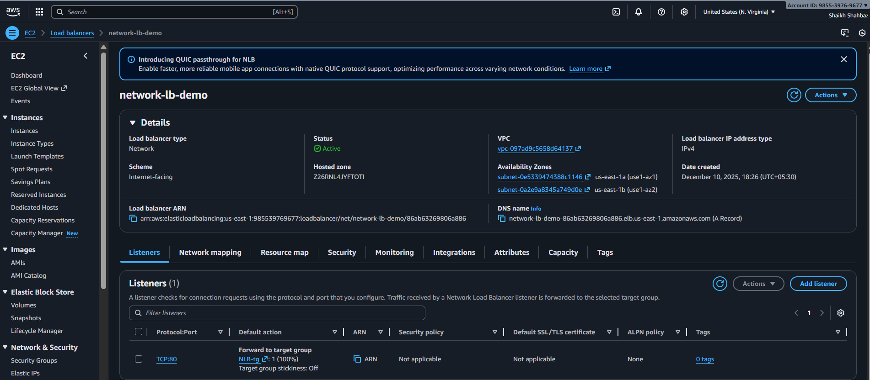
Validation Steps
Validation 1: Resource Health
Check:
- Both EC2 instances are healthy under Target Group
- NLB status is active
Evidence:
Screenshot of "healthy" target status
Validation 2: Functional Check
Check:
Access NLB DNS name:
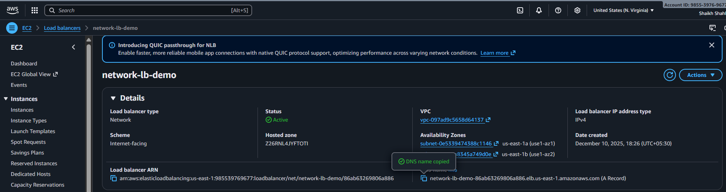
http:// network-lb-demo-86ab63269806a886.elb.us-east-1.amazonaws.com
Refresh multiple times → responses alternate between:
- “Welcome from Instance 1”
- “Welcome from Instance 2”
Evidence:
Browser screenshot showing output from different instances
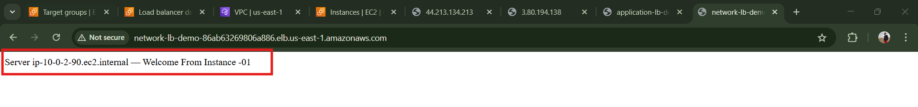
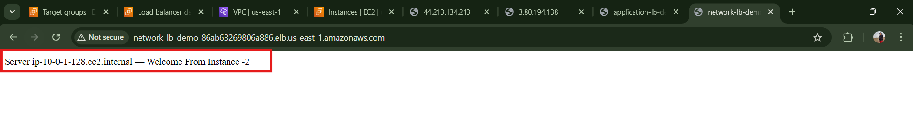
Validation 3: Network Check
From instance, verify web server is responding:
curl localhost
Expected Output:
Welcome from Instance 1
Evidence:
Terminal output screenshot
Issues Faced (Optional)
Issue | Fix
Health check failing | Ensure port 80 is open in EC2 SG
Instances remain unhealthy | Use TCP health checks instead of HTTP
No response from NLB | Verify subnets are public + route table has IGW

Conclusion
You have successfully configured a Network Load Balancer that:
Operates on Layer 4 (TCP)
Handles massive throughput
Distributes traffic across multiple AZs
Provides high availability + low latency

4.Attach SSL for application load balancer.
Task Title
Attach SSL Certificate to an Application Load Balancer (HTTPS Listener Configuration)
Objective
Enable secure encrypted communication (HTTPS) on an Application Load Balancer using an SSL/TLS certificate issued by AWS Certificate Manager (ACM).
Prerequisites
Before starting, ensure the following:
- VPC
- Public Subnets (at least 2 for ALB)
- Application Load Balancer already created
- Target Group created and attached
- Domain Name (shaikhshahbazz.online)
- Hosted Zone in Route 53
- ACM Certificate (Pending or Issued)
- Security Group allowing port 443
- IAM permissions for ACM + ELB

Step-by-Step Implementation

Step 1: Request SSL Certificate in ACM
Console Path:
AWS Console → Certificate Manager → Request Certificate → Request Public Certificate
Actions:
- Enter domain name (e.g., www.shahbazz.com)
- Select DNS Validation
- Confirm
Evidence (Expected Screenshot):
- ACM shows certificate status Pending validation
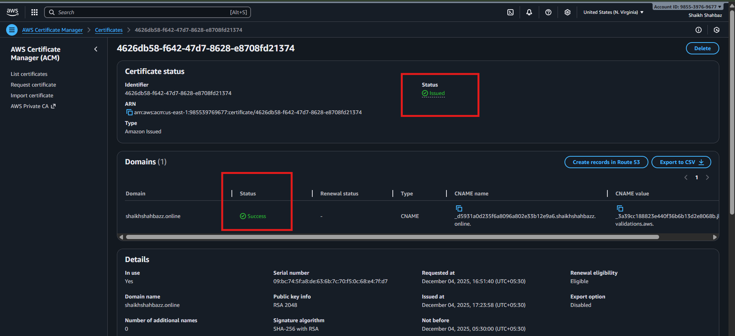
Step 2: Validate the SSL Certificate (DNS Validation)
Console Path:
ACM → Your Certificate → Create CNAME Record in Route 53
Actions:
- Click Create Record in Route 53
- Wait 1–5 mins
Evidence:
- Status changes to Issued
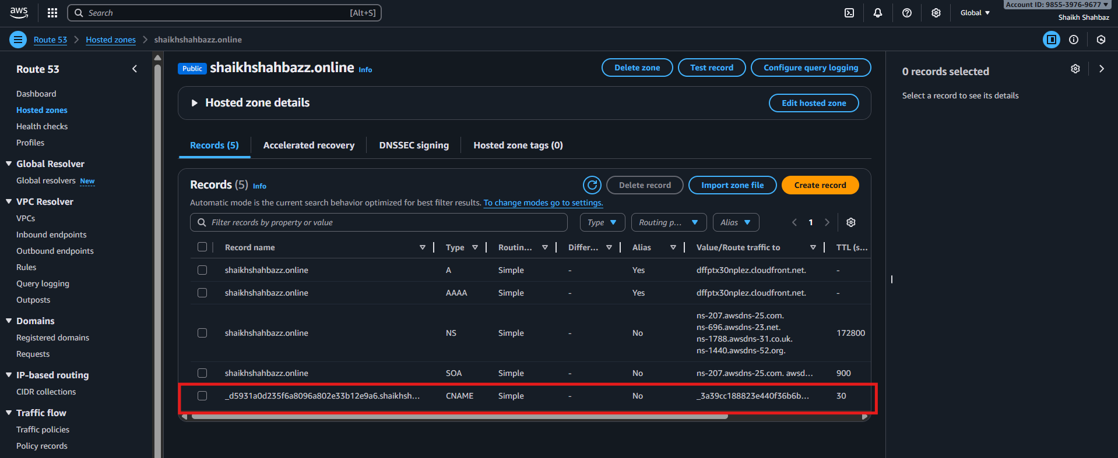
Step 3: Open ALB Listener Settings
Console Path:
EC2 → Load Balancers → Select ALB → Listeners
Actions:
- Click Add Listener
- Choose:
  - Protocol: HTTPS
  - Port: 443
Evidence:
- HTTPS listener creation pop-up visible
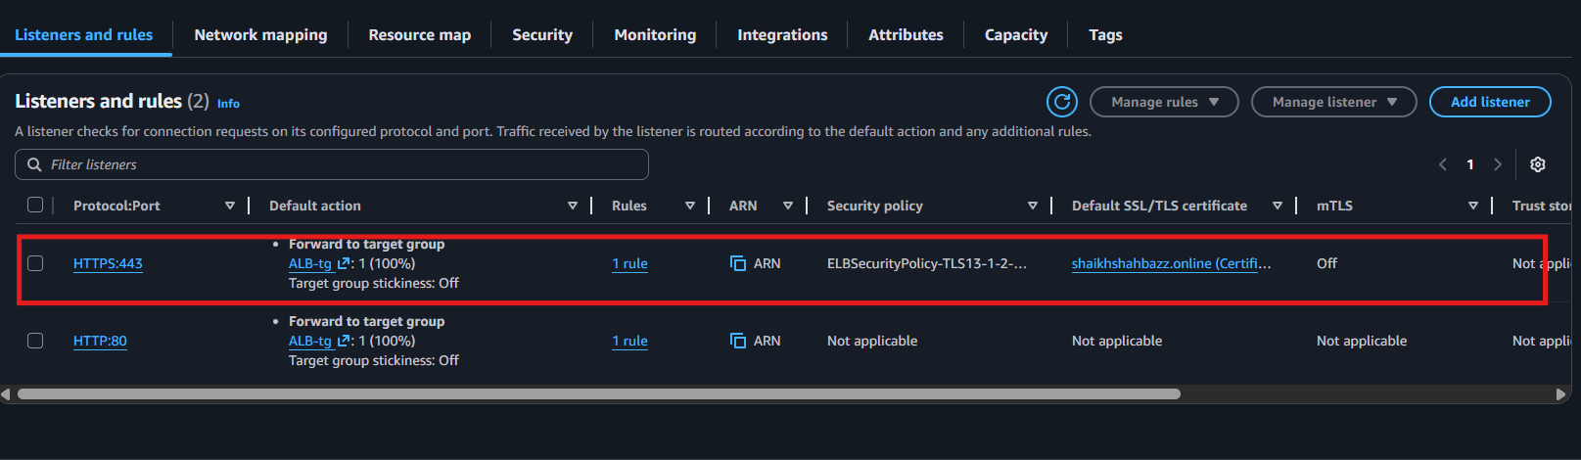
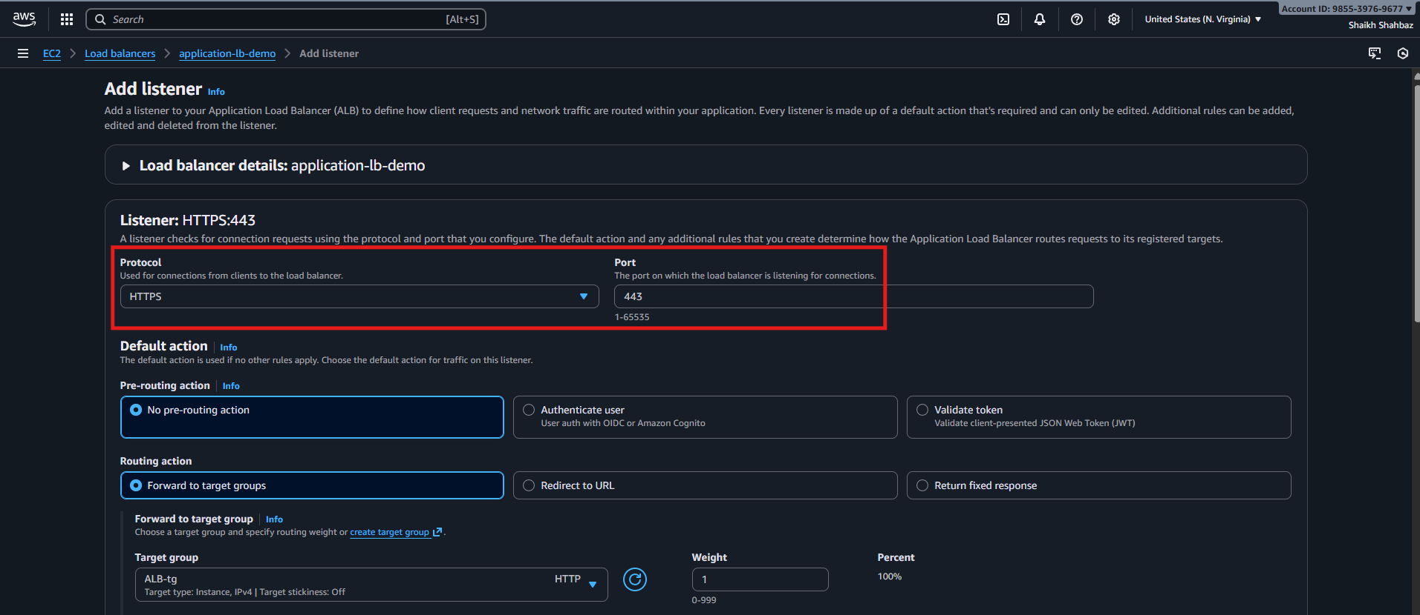

Step 4: Attach SSL/TLS Certificate
Console Path:
When adding HTTPS listener ↓
→ Choose ACM Certificate
→ Select: *.shahbazz.com
Actions:
Forward to: Existing Target Group
Evidence:
- Certificate attached under HTTPS listener
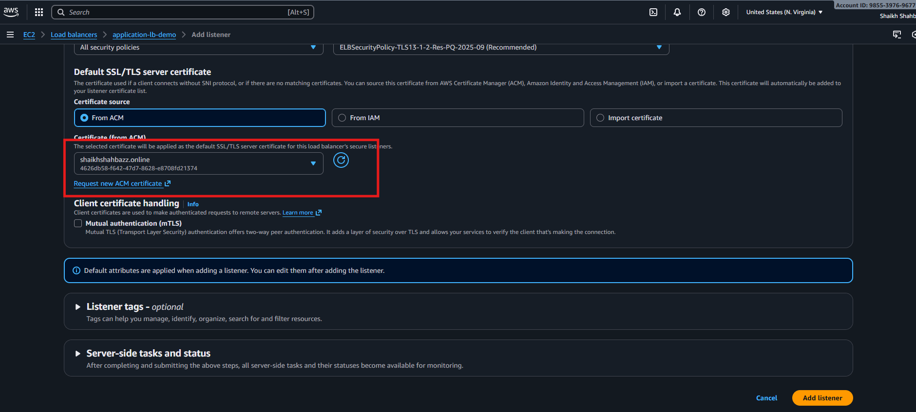
Step 5: Update Security Group for ALB
Console Path:
EC2 → Load Balancers → Select ALB → Security
Actions:
- Allow Inbound 443 from 0.0.0.0/0
Evidence:
- Security group rule visible: 443 open

Validation Steps
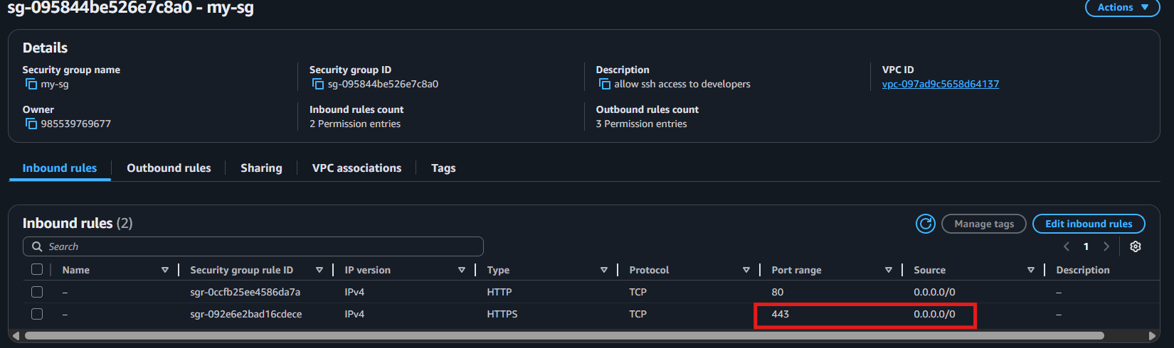
Validation 1: Certificate Status
Check ACM certificate shows Issued.
Evidence:
Screenshot of ACM certificate status = Issued.
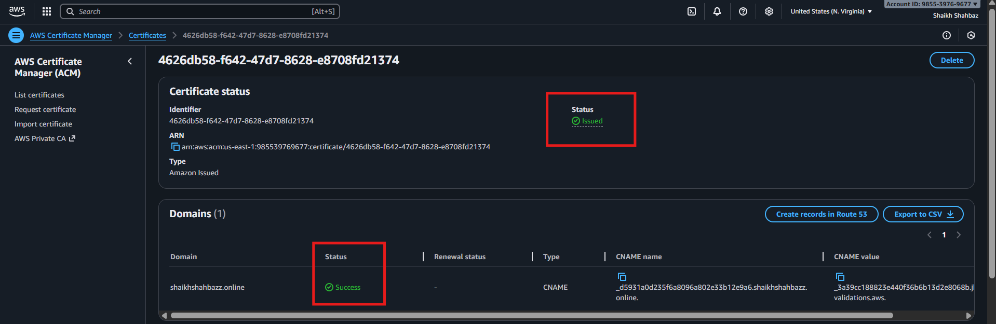
Validation 2: HTTPS Listener Active
Go to ALB → Listeners → verify:
HTTPS : 443 → healthy target group
Evidence:
Listener tab showing HTTPS
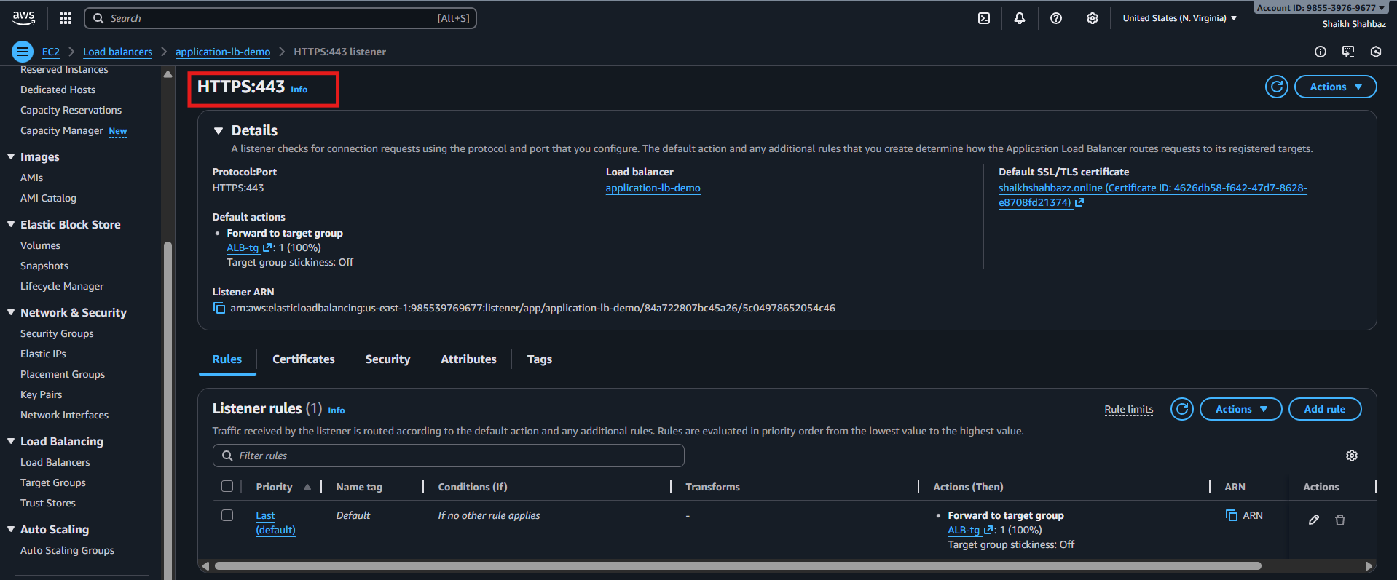
Validation 3: Open Website Using HTTPS
Open:
https://www.shahbazz.online
Expected Result:
- Page loads
- Browser shows “Secure” padlock icon
Evidence:
Screenshot of secure (HTTPS) website page.
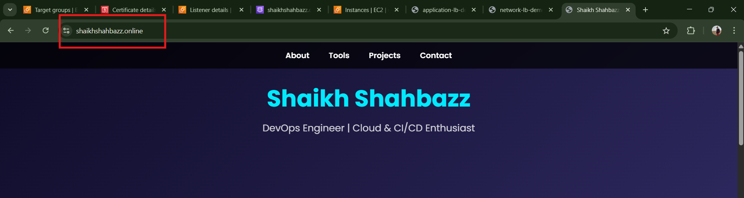
Issues Faced (Optional)
Issue: Certificate stuck in “Pending Validation”
Fix: Ensure Route 53 DNS automatically added the CNAME record correctly.
Issue: HTTPS not opening
Fix: Open port 443 in ALB security group.
Conclusion
You successfully configured SSL/TLS on your Application Load Balancer, securing your application with HTTPS and ensuring encrypted traffic from users to the ALB.

5.Map Application load balancer to R53.
Task Title
Map Application Load Balancer to Route 53 Hosted Zone
Objective
Point a custom domain (example: www.shahbazz.com) to the ALB DNS using Route 53 so users can access the application through a clean domain instead of the long ALB hostname.
Prerequisites
- VPC
- Public Subnets (ALB must exist in at least 2 AZs)
- Application Load Balancer (already created)
- Target Group attached to ALB
- Route 53 Hosted Zone (Domain registered in Route 53 or external domain with NS mapped)
- Security Groups
- IAM Permissions for Route 53, ELB
- SSL Certificate (optional if HTTPS used)

Step-by-Step Implementation
Step 1: Identify ALB DNS Name
Console Path:
EC2 → Load Balancers → Select your ALB → Description tab
Example ALB DNS:
application-lb-demo-1746789976.us-east-1.elb.amazonaws.com
Explanation:
This DNS name will be mapped in Route 53.
Evidence:
Screenshot Placeholder
(Shows ALB description with DNS name highlighted)
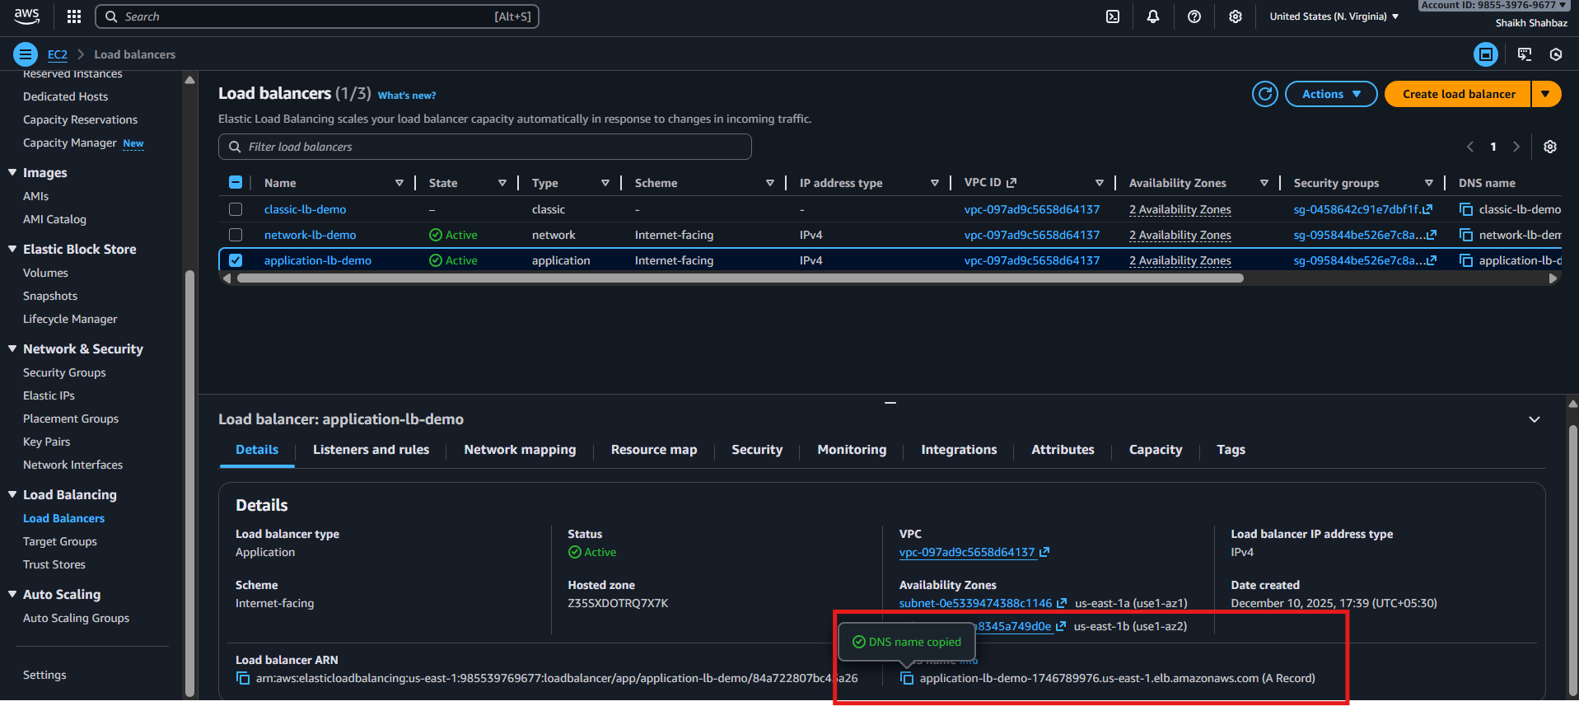
Step 2: Open Route 53 Hosted Zone
Console Path:
Route 53 → Hosted Zones → Select domain ( shaikhshahbazz.online)
Explanation:
We will create an alias A-Record pointing to ALB.
Evidence:
Screenshot Placeholder
(Hosted Zone records list visible)
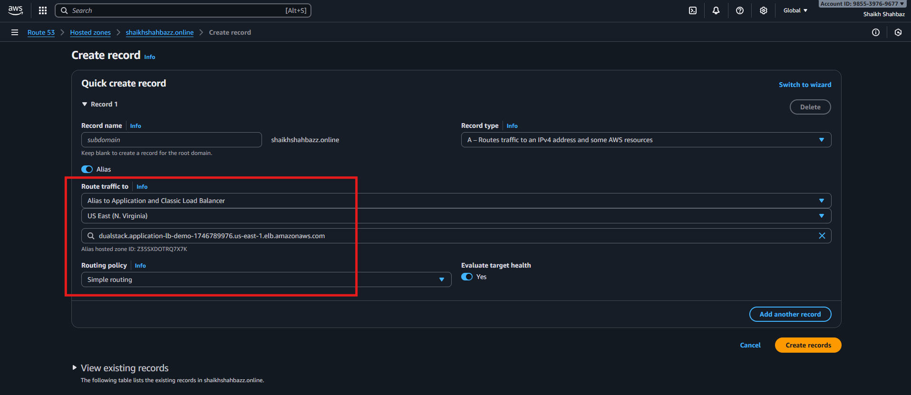

Step 3: Create A Record (Alias to ALB)
Console Path:
Hosted Zone → Create Record
Fill values:
Field | Value
Record Name | www (or blank for root domain)
Record Type | A (IPv4 Address)
Alias | Yes
Alias Target | Select ALB from dropdown
Routing Policy | Simple
Evaluate Target Health | Yes
Explanation:
Route 53 automatically resolves the ALB alias target—even if AWS changes the ALB IP internally.
Evidence:
Screenshot Placeholder
(Record creation screenshot showing ALB selected)

Step 4: Save the Record
Click Create Records.
Explanation:
The domain will now resolve to the ALB.
Evidence:
Screenshot Placeholder
(Record successfully created)
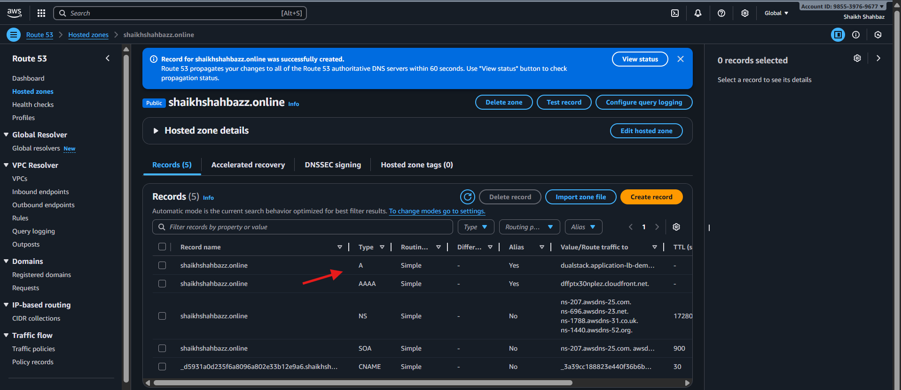
Validation Steps (Mandatory, With Evidence)
Validation 2: Browser Test
Open:
http://www.shahbazz.com
OR if SSL attached:
https://www.shahbazz.com
Expected Result:
Application loads from EC2 via ALB.
Evidence:
Browser screenshot placeholder
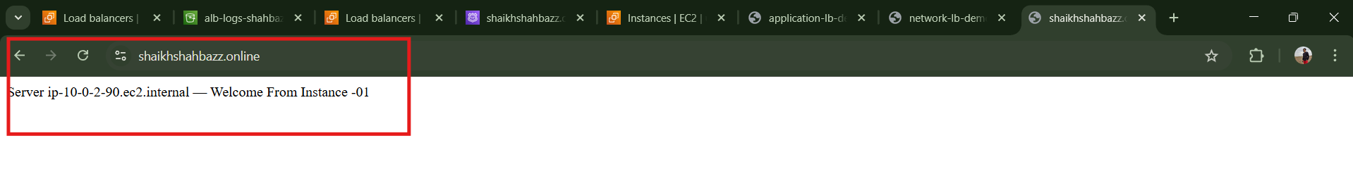

Issues Faced (Optional)
Issue | Cause | Fix
ALB not appearing in Route 53 | ALB not in same region | Use correct region
Domain not resolving | DNS propagation delay | Wait 1–5 minutes
Browser shows error | SG/Listener misconfig | Allow port 80/443 properly

Conclusion
You successfully mapped the Application Load Balancer to Route 53, enabling your application to be accessed through a clean custom domain. This improves user experience and supports HTTPS setups and global traffic routing.

6.Push the application load balancer logs to S3
Task Title
Enable and Store Application Load Balancer (ALB) Access Logs in S3 Bucket
Objective
Configure ALB access logs to automatically store request data (source IP, target IP, response time, latency) into an S3 bucket for auditing, analysis, and security compliance.
Prerequisites
- VPC
- Public Subnets
- Existing Application Load Balancer
- S3 bucket created for logs
- Correct bucket policy for ELB logging
- IAM Permissions:
  - s3:PutObject
  - s3:GetBucketPolicy
  - elasticloadbalancing:*
- Route Tables
- Security Groups
Step-by-Step Implementation (With Evidence)
Step 1: Create an S3 Bucket for ALB Logs
Console Path
S3 → Create bucket
Configuration
- Bucket name: alb-logs-shahbazz
- Region: same as ALB
- Block Public Access: Enabled
- Versioning: optional
- Encryption: Enabled (AES-256)
Evidence:
(Add screenshot here)
S3 bucket creation screen.
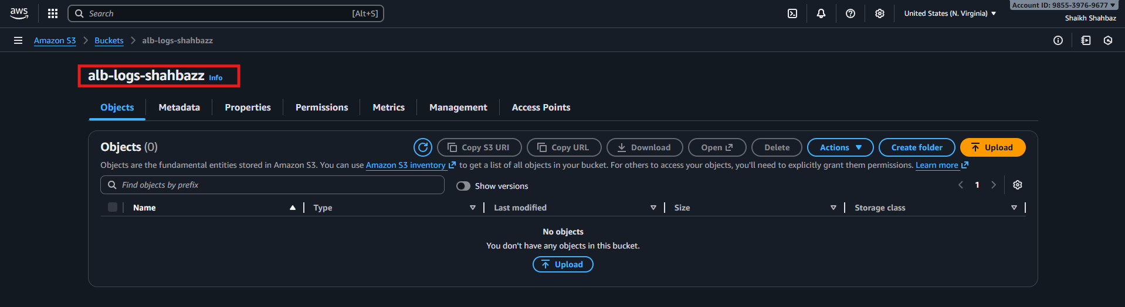
Step 2: Attach AWS-Required Bucket Policy for ALB Logging
Console Path
S3 → Bucket → Permissions → Bucket Policy → Edit
Policy (replace bucket name + region + account ID)
{
"Version": "2012-10-17",
"Statement": [
{
"Sid": "AWSALBAccessLogs",
"Effect": "Allow",
"Principal": {
"Service": "logdelivery.elasticloadbalancing.amazonaws.com"
},
"Action": "s3:PutObject",
"Resource": "arn:aws:s3:::alb-logs-shahbazz/AWSLogs/<ACCOUNT-ID>/*"
}
]
}
Explanation
- Allows ELB service to upload log files into S3.
Evidence:
(Add screenshot of bucket policy applied)
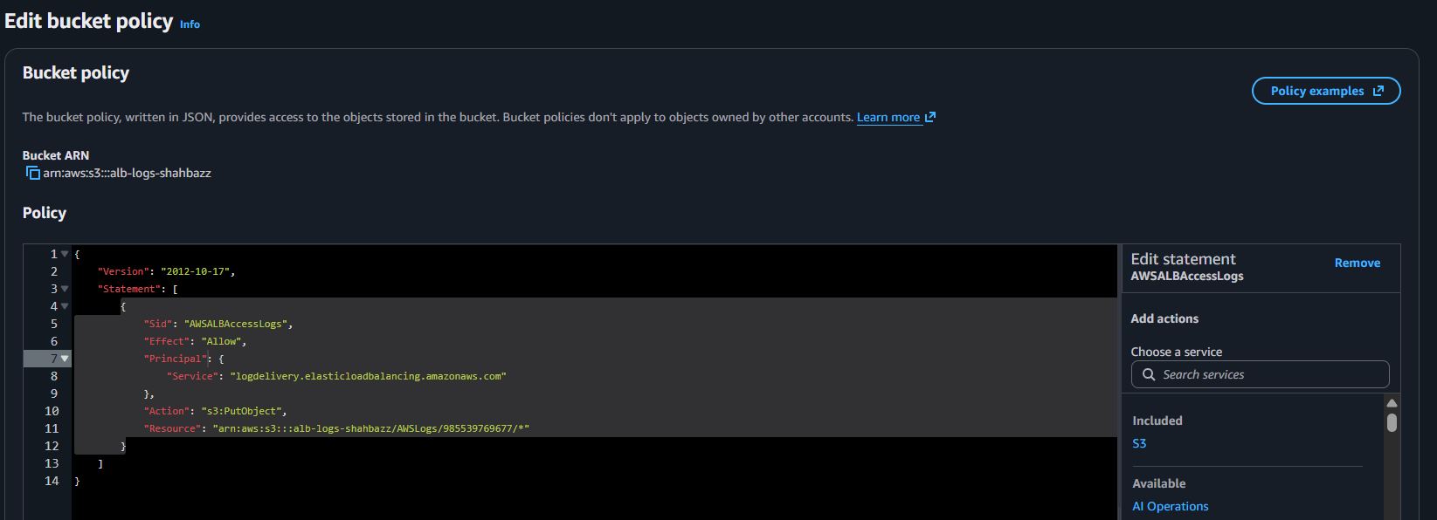
Step 3: Enable Access Logs on the Application Load Balancer
Console Path
EC2 → Load Balancers → Select ALB → Attributes
Steps
- Scroll to Access Logs
- Click Edit
- Enable Access Logging: ON
- Select S3 bucket: alb-logs-shahbazz
- Prefix (optional): alb/
- Save
Explanation
This enables the ALB to periodically push logs in gzip format to S3.
Evidence:
(Screenshot of ALB Access Logs enabled)
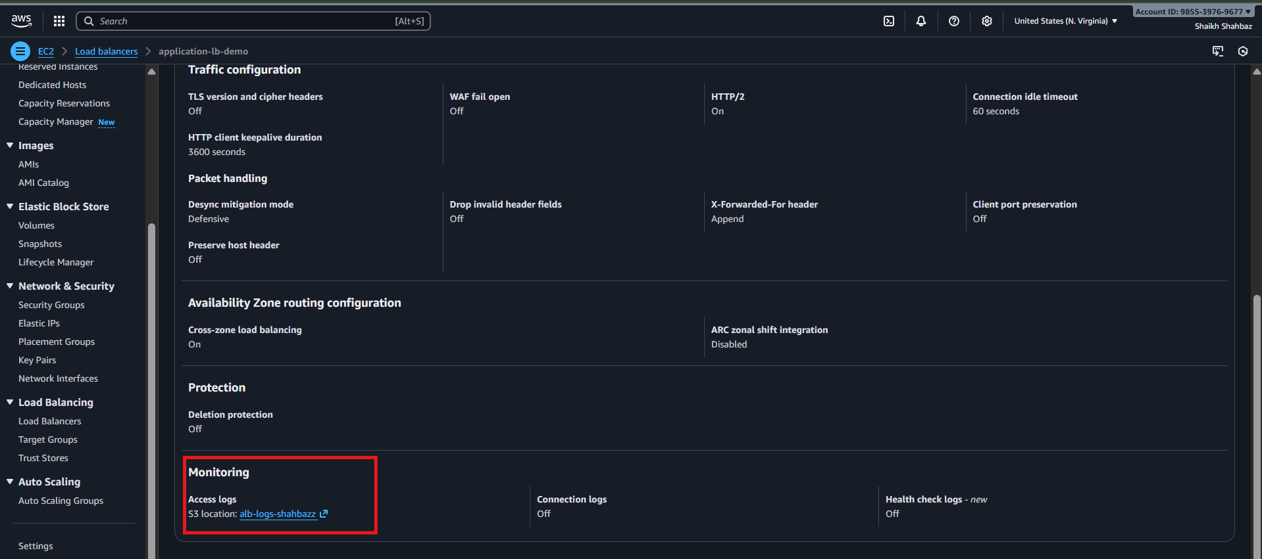
Step 4: Validation That Logs Are Being Delivered
Console Path
S3 → alb-logs-shahbazz → AWSLogs → <account-id> → elasticloadbalancing → <region>/
What You Should See
Files named like:
2025-01-10T12-25-59.abc123.log.gz
Evidence:
(Screenshot of S3 folder containing ALB log files)
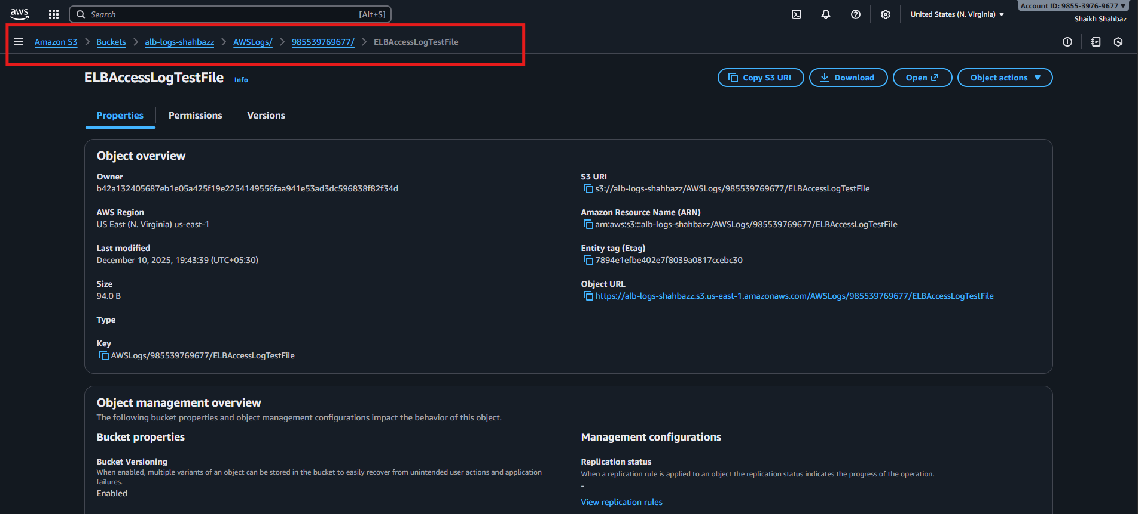
Validation Steps
Validation 2: Confirm S3 Bucket Contains Logs
Navigate to:
s3://alb-logs-shahbazz/AWSLogs/<account-id>/elasticloadbalancing/<region>/
Expected: .log.gz files appear every 5 minutes.
Evidence:
(Screenshot of log files in S3)
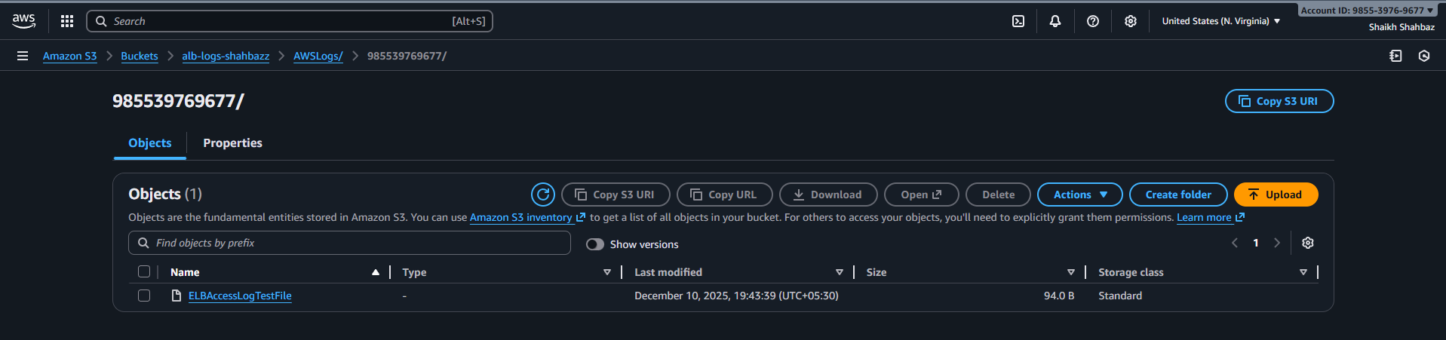
Issues Faced (Optional)
Issue: ELB could not write logs into S3
Fix: Bucket policy was missing the correct service principal
logdelivery.elasticloadbalancing.amazonaws.com
Issue: No logs appearing
Fix: ALB had no traffic → hit ALB DNS from browser to generate traffic.
Conclusion
The Application Load Balancer is now successfully configured to push access logs to S3 for monitoring, security analytics, and troubleshooting. Logs are generated every 5 minutes and stored in a structured format for long-term retention and analysis.

